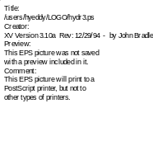 | Center for Computational  Hydroscience and Engineering

FRAME – Control Module Technical Manual
Technical Report No. CCHE-TR-97-7 |  | Rev. 2 – February, 1999
Dalmo A. Vieira

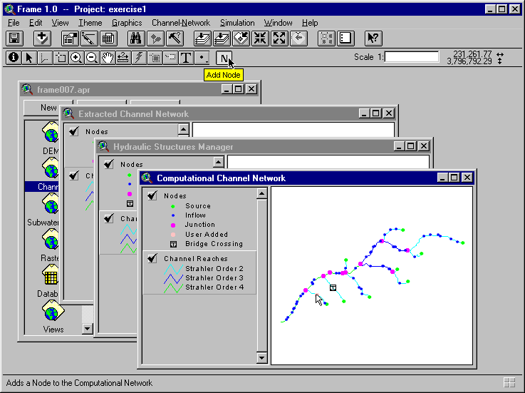
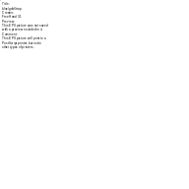 | School of Engineering  The University of Mississippi  University, MS 38677

Center for Computational

Hydroscience and Engineering

Technical Report No. CCHE-TR-97-7

FRAME – Control Module Technical Manual

Dalmo A. Vieira

Research Associate

The University of Mississippi

Revision 2

October, 1999

Contents
CHAPTER 1 Introdution 1
1.1 Purpose 1
1.2 Applicability Statement 1
1.3 How To Read This Manual 2
1.4 Related Documents 2
CHAPTER 2 Overview 4
2.1 FRAME as an Extension to ArcView 4
2.2 Frame Models And Tools 6
2.3 Frame Program Structure 8
2.4 System Of Units 9
CHAPTER 3 Landscape Analysis and Channel Network Extraction 10
3.1 TOPAZ-DEDNM 10
3.1.1 Introduction 10
3.2 DEM Pre-Processing 11
3.2.1 Pre-processing Algorithms 11
3.2.2 Importing a DEM 12
3.2.3 Pre-Processing a DEM 13
3.3 Channel Network Extraction 15
3.3.1 Algorithms 15
3.3.2 Operation Control 16
3.3.3 Channel Network Extraction Parameter Sets 17
3.3.4 Channel Network Extraction 19
3.3.5 Watershed Delineation 20
3.4 Frame Network Database 22
3.4.1 Introduction 22
3.4.2 Channel Network Logical Organization 22
3.4.3 Node Numbering Scheme 24
3.4.4 FRAME Channel Junctions 25
3.4.5 FRAME Links and their Computational Sequence 26
3.4.6 FRAME/SWAT Subwatersheds 26
3.4.7 Database Tables 27
3.5 Program Control 34
3.5.1 Importing and Pre-Processing DEMs 34
3.5.2 Extracting the Channel Network 35
3.6 Input And Output Files 36
3.6.1 Digital Elevation Models 36
3.6.2 DEM Pre-Processing 37
3.6.3 Channel Network Extraction 38
3.6.4 Watershed Delineation 39
CHAPTER 4 Channel Network Analysis 41
4.1 Introduction 41
4.2 Cross Section Data Management 42
4.2.1 Cross Section Data 42
4.2.2 Flow Model Requirements 42
4.2.3 Cross Section Geometry Database Table 43
4.2.4 Bed Sediment Database Table 45
4.2.5 Bank Sediment Database Table 46
4.2.6 Sediment Grain Distribution Database Table 47
4.2.7 Sediment Class Definition Database Table 48
4.2.8 Graphical User Interface Features 48
4.2.9 Importing a File 49
4.2.10 Entering data 50
4.2.11 Editing data 50
4.2.12 Editing a table 50
4.2.13 Checking for Nodes with Missing Data 51
4.2.14 Interpolation 51
4.3 Hydraulic Structures Data Management 52
4.3.1 Flow Model Requirements 52
4.3.2 Hydraulic Structure Database Tables 53
4.3.3 The Hydraulic Structure Management Window 56
4.3.4 Importing a File 57
4.3.5 Adding a Hydraulic Structure 57
4.3.6 Editing Hydraulic Structure Data 58
4.3.7 Cross Section Data 58
4.3.8 Effects on the Network Database 58
4.4 Computational Mesh Generation 59
4.4.1 Introduction 59
4.4.2 The Computational Channel Network Window 60
4.4.3 Rules for Node Addition 61
4.4.4 Adding Computational Nodes 63
CHAPTER 5 Flow and Sediment Routing 65
5.1 Introduction 65
5.2 Input Parameters And Data Files 66
5.2.1 Types of Simulation Runs 66
5.2.2 Control Parameters 67
5.2.3 Boundary Conditions File 67
5.2.4 Visualization 68
5.2.5 Chart Definition Database Table 68
APPENDIX A References 70
APPENDIX B Hydraulic structure input data 72
Bridge Crossings 73
Culverts 74
Drop Structures 85
Measuring Flumes 86
APPENDIX C Data File Formats 88
Digital Elevation Model Files 89
ArcInfo ASCII Grid 89
Cross Section Files 90
ASCII Format 91
Dbase Format 92
Bed Sediment Files 93
ASCII Format 93
Dbase Format 94
Bank Sediment Files 95
ASCII Format 95
Dbase Format 98
Grain Size Distribution Table 98
Sediment Classes Definition Table 99
Hydraulic Structures File 100
Boundary Conditions Files 102
Watershed-Oriented Format 103
Colormap File 109

CHAPTER 1
INTRODUCTION

Purpose
The purpose of this manual is to provide analysts and programmers of FRAME – Fluvial Routing Analysis and Modeling Environment – with the information necessary to effectively maintain and modify its interface and its program control module, both programmed in the Avenue language. FRAME is distributed as an Extension to the Geographic Information System (GIS) ArcView. An Extension is an add-on program that provides specialized functionality to ArcView. This manual documents the implementation of the interface and control module. It provides a detailed description of all the procedures and methodologies employed in the program. It also discusses the program's algorithms, data structures, capabilities and limitations.
This is a technical manual and is not intended as the User's Manual, which is a separate publication. This manual does not cover the modeling components themselves. For reference documents on the underlying models of FRAME, consult the publication list under 1.4 Related Documents.

Applicability Statement
This manual applies to FRAME version 1.0 Beta, of February 1999. FRAME 1.0 requires the ArcView GIS version 3.0a or later. Early versions of ArcView 3.0 for the Windows 95 and NT environments, require a patch available from Environmental Systems Research Institute, that can be found at http://www.esri.com.

How To Read This Manual
This manual discusses all the features of FRAME for the version stipulated in 1.2 Applicability Statement. Chapter 2 gives an overview of the system and its features, introducing the modeling components of FRAME and discussing the structure of the software.
Chapter 3 presents the Landscape Analysis module. It documents the procedures related to the extraction of a channel network from a Digital Elevation Model. It also describes in the detail the structure of the FRAME Network Database.
Chapter 4 discusses the Channel Analysis module, describing the procedures for entering and managing input data and the algorithms for the generation of the computational channel network.
Chapter 5 describes the flow simulation module. It documents the management of input data and control of the flow and sediment transport models.
Appendix A contains a list of references. Appendix B describes the input data for the supported hydraulic structures. Appendix C documents the format of all input files FRAME requires.

Related Documents
The documentation of FRAME is separated into several publications designed to fulfill the needs of different audiences. The present document, the FRAME Control Module Technical Manual, is intended primarily to analysts and programmers interested in maintain or modify FRAME. . It documents the functional organization of FRAME, its tasks and procedures, and the data storage structures.
Other publications cover aspects such as applying FRAME to a watershed analysis, modeling assumptions and methodologies, validation and verification of modeling components, software design, and computer program implementation.
The publications that document the FRAME software package are:
- FRAME – User’s Manual. This publication is intended to end users who will apply FRAME to the simulation of a watershed system. It explains how to use FRAME’s modeling components and auxiliary tools effectively. This manual gives systematic instructions on how to perform all tasks and operations of the modeling process.
- Discretization Diffusion Wave Model. This report describes the mathematical model DWAVNET, its governing equations, discretization and numerical solution. (Langendoen, 1996).
- DWAVNET: Modifications to Friction Slope Formulation and Solution Method. This report discusses tests and improvement to the description of friction slope in the channel flow model DWAVNET. (Langendoen, 1997).
- An Introduction to BEAMS (Bed and Bank Erosion Analysis Model for Streams). This report discusses the development of the sediment transport and bank analysis model that is integrated with the flow model DWAVNET. (Zhang and Langendoen, 1998).

OVERVIEW

FRAME as an Extension to ArcView
FRAME is an integrated software package to simulate watershed, and channel flow and sediment routing processes. FRAME is composed of several modeling components, tied together by a control module that provides a Graphical User Interface (GUI) and manages all data sets and operations. This manual describes in detail this Control Module.
The Control Module of FRAME uses the Geographic Information System ArcView® as a front-end interface. FRAME is an Extension to ArcView that provides the needed functionality. After installation, the user can turn on the FRAME functionality from within ArcView. When the FRAME extension is active, a set of menus and buttons is appended to the standard ArcView interface. These controls let the user perform all operations related to FRAME. FRAME generates map displays to show channel networks, subwatersheds, etc. Following the ArcView Shapefile concept for spatial data storage, each map display (called a View) is accompanied of a database Table, and an auxiliary Index file. FRAME uses some tables that do not have a graphical counterpart. They are primarily for storage of data and for the logical organization of the database.
All persistent data are stored in a relational database. It consists of a series of tables logically connected through indices, called IDs. FRAME manages the data relationships between these tables, updates their contents and verifies their integrity.
The FRAME extension is not only a customized GUI. Many operations are performed within ArcView to take advantage of its database management capabilities and automatic map composition features. Also, FRAME generates, organizes and converts data to create suitable input for each of the modeling components.
The distributed FRAME Extension contains the interface features and programs necessary to perform all operations. It also organizes documents (graphic views and database tables) according to their type. For each type of document, a customized GUI is provided. Each GUI allows the user to perform only a restricted number of operations. This helps reduce the number of menus and buttons and guides the user during the application of the program.
The FRAME Extension does not eliminate any of the standard ArcView features. It just adds new functionality, by supporting new types of specialized Documents, such as the Channel Network Map. Furthermore, if the user has previously modified the standard ArcView interface, FRAME does not interfere with any user customization.
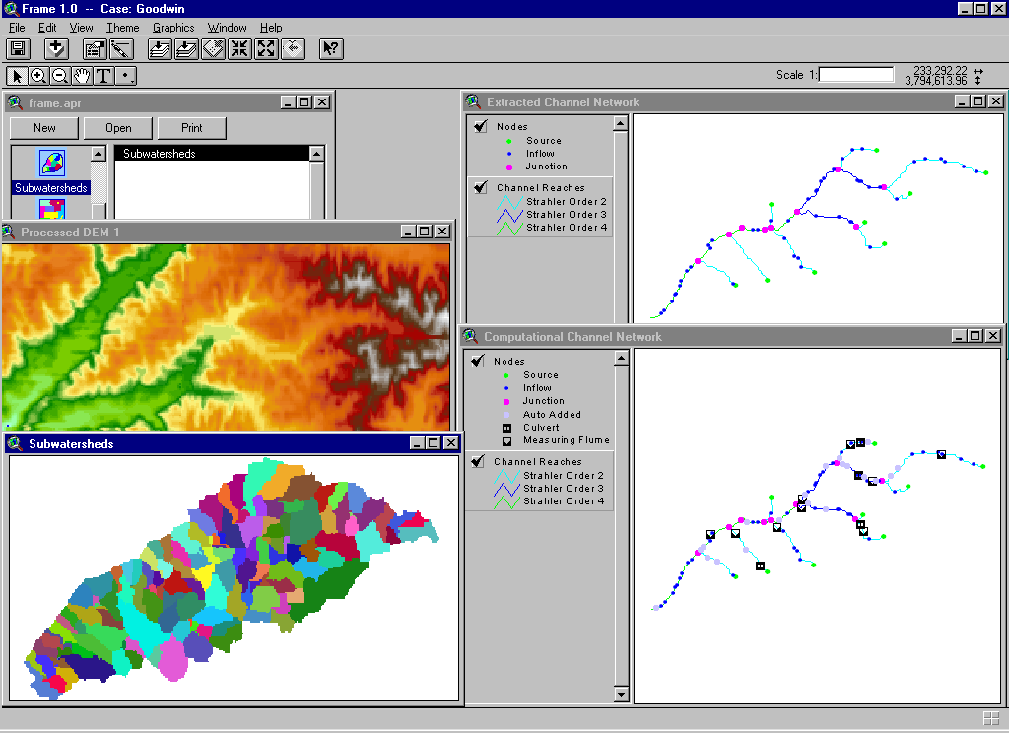All the work done with FRAME is stored in a file called a Project. File names have the extension .apr. The Project window gives the user access to all components contained in the Project file. The Project window contains a series of icons, which represent different types of document. These icons help in the organization of the Project by grouping similar documents. When the FRAME interface is active, five new document types are supported:
- DEMs
- Channels
- Subwatersheds
- Rasters
- Database
When a certain document is active, that is, it was selected by the user by clicking on it or by highlighting its name from the Project window, a specialized GUI is automatically activated. All menus and buttons at the top of the ArcView application window change to show those that relate to actions to be performed on the document currently selected. These actions will either modify the current document, or create a new one, derived from the selected document.

Frame Models And Tools
FRAME distinguishes three steps in the simulation of watershed and flow routing problems. FRAME was designed to make this separation clear, since their use is sequential and the output of one step is used as input for the next.
FRAME provides the capability of extracting the channel network and subwatersheds information from a Digital Elevation Model (DEM). This capability is provided by the landscape analysis model TOPAZ – TOpographic PArameteriZation. FRAME simplifies the preparation of input to TOPAZ by reducing the amount of information the user has to supply. It stores the data generated by TOPAZ and provides means of visualizing the results.
FRAME automatically extracts the channel network from the DEM. The watershed is delineated, and subwatersheds corresponding to each link in the channel network are defined. The user can control the appearance of the extracted channel network (channel density, minimum channel lengths, etc.) through two calibration parameters. The interface helps the user define the set of parameters. For a DEM to be used successfully by TOPAZ, it cannot have depressions and flat areas. For this reason, a pre-processing operation is necessary. FRAME makes sure that the DEM is pre-processed before attempting to extract the channel network. Maps showing the channel network and the subwatersheds are automatically displayed.
After the channel network is extracted and displayed on screen, FRAME guides the user through the second step, which is the process of providing supplemental data and creating a computational mesh for the channel flow simulation models. The starting point is the definition of channel cross section data. The user has to provide a series of points that define the shape of the channel at the beginning and end of each channel link. This information can be provided interactively by selecting a point and typing the distance and elevation values, or alternatively, by importing a data file containing this information.
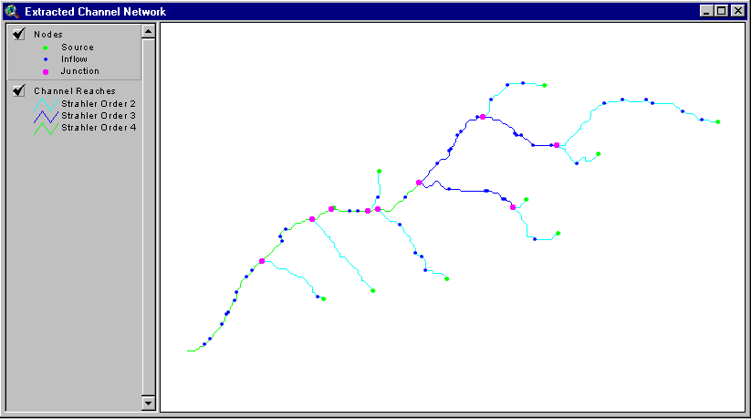With the cross-sectional information available, the user has the option of inserting hydraulic structures in the network. The present version supports four types of structures (culverts, drop structures, measuring flumes, and bridge crossings). For this task, FRAME creates a separate map, which is used solely for this purpose. It is named the Hydraulic Structures Manager. Similarly to the input of channel cross sections, the user can select a point in the network where a hydraulic structure is to be inserted, or import a file containing the necessary information.
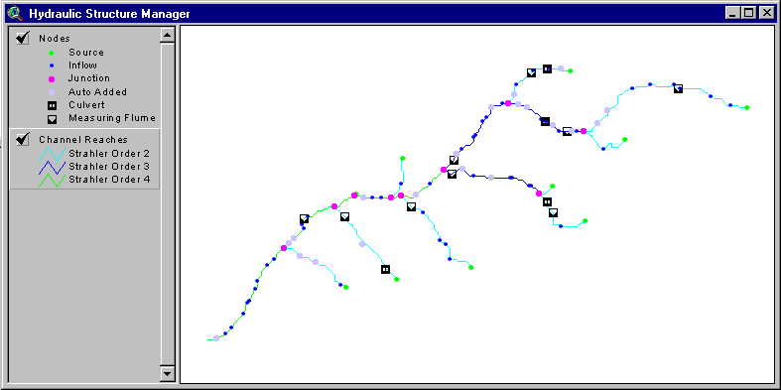After the channel cross section data are ready and all hydraulic structures were defined, FRAME automatically generates the Computational Channel Network. This is the computational mesh to be used by the flow and sediment routing models. FRAME analyzes the geometry and topology of the channel network to determine if it is adequate for the numerical simulations. FRAME adds computational nodes to the network, so that the computational mesh will match the convergence and accuracy requirements the simulation models impose.
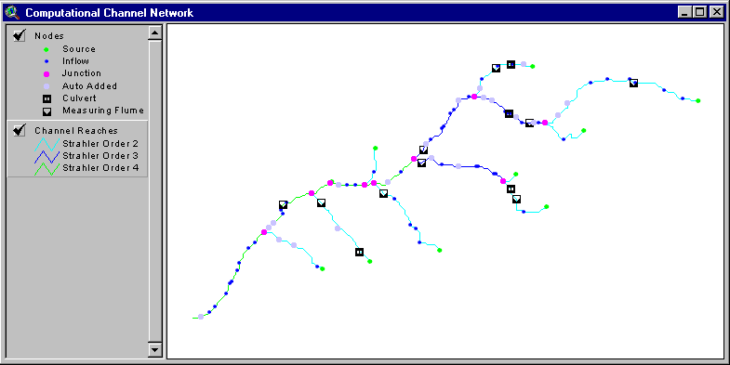Once the Computational Channel Network is created, the Simulation step can begin. FRAME guides the user by helping with the input of data and control parameters, and by controlling the execution of the simulation runs. FRAME uses the channel flow routing model DWAVNET and its companion, the sediment transport model BEAMS.
This manual discusses the technical details of the implementation of the control of and interface to each operation. It is structured to approximately follow the order in which operations are performed. Chapters 3 to 5 discuss the procedures and algorithms in general. They are intended to an analyst who is interested in understanding how the model works, but not in the details of code implementation. For a comprehensive documentation of the computer code, and information necessary for code maintenance or modification, please refer to the publication “FRAME – Software Design and Implementation.”

Frame Program Structure
FRAME can be considered as two large groups of programs:
- The ArcView Extension, which is the “visible” part of the system and takes care of the program-user interface.
- A set of modeling programs and auxiliary tools, which operate as black boxes to the user.
The Extension is entirely programmed in Avenue, an object-oriented language used to program the GUI and all tasks that are performed within ArcView. These programs prepare the data for and control the execution of other programs. The Extension also contains the programs that perform the Channel Network Analysis, the module that creates the computational network to be used by the flow and sediment transport models.
The modeling components are programmed in Fortran 77 and ANSI C. They are executed by Avenue programs according to user actions upon the GUI. In order to facilitate the portability of the program and have FRAME available for both Unix and PC environments, all data transfers are made through data files written to disk.
Three programs are called by the Control Module:
- frmxtr, responsible for the channel network extraction, it includes all the TOPAZ-DEDNM functionality.
- frmdwv, a front-end to the channel flow and sediment routing models DWAVNET and BEAMS.
- ascii2tif, a tool to convert a raster map in ASCII format to a monochrome TIFF image. It is used to convert DEM files for displaying in FRAME.

System Of Units
FRAME and all its modeling components support only the International System of Units (SI).

Landscape Analysis and Channel Network Extraction

TOPAZ-DEDNM

Introduction
FRAME uses a modified version of TOPAZ (TOpographic PArameteriZation). Only the Channel Network Extraction module, called DEDNM (Digital Elevation Drainage Network Model) is included in FRAME. There are no modifications to any of DEDNM's algorithms or their code implementation. However, in order to adequately couple DEDNM to the FRAME system, modifications were made to DEDNM's main subroutine.

Flow of Operations
The original implementation of TOPAZ-DEDNM allowed the user to perform the network extraction process by defining separate, consecutive tasks. By setting option values in the input file the user could:
- Pre-process the DEM, Extract the Channel Network and perform the Watershed Definition.
- Perform only the Pre-processing of the DEM.
- Rerun the Watershed Definition part with a new watershed outlet.
- Rerun the Network Extraction part with new parameters and the Watershed Definition part with a new watershed outlet.
FRAME maintains all these possibilities, but to improve interactivity, some modifications were made to the code structure. TOPAZ-DEDNM requires the user to select the watershed outlet. This was done in the middle of code execution. Since within FRAME the modeling components are independent programs that are not designed to share data during execution, TOPAZ-DEDNM was modified to execute each of the tasks independently, saving all the information to files in the computer disk.

Program Structure
The program frmxtr, which replaces the original DEDNM module, separates the whole process into three steps:
- Pre-processing of the DEM: According to user options and parameters, a DEM file is read, and then modified to make it suitable for the channel network extraction, thus creating a new DEM raster.
- Channel Network Extraction: Using the processed DEM, the TOPAZ-DEDNM algorithms extract the channel network, saving all pertinent information.
- Watershed Delineation: Using the results from the Channel Extraction phase and the coordinates of the watershed outlet, selected interactively through the GUI, the TOPAZ-DEDNM algorithms determine the watershed boundaries and delineate all subwatersheds. In addition, during this phase an extension to the original TOPAZ-DEDNM program creates a database containing all information about the channels and subwatersheds. This database is discussed in detail in the next section.

DEM Pre-Processing

Pre-processing Algorithms
The extraction of a channel network from a Digital Elevation Model requires that the DEM go through a sequence of preparation algorithms. These algorithms ensure that the DEM is suitable for the determining of a convergent network of flow paths. Ordinarily, a DEM contains flat areas and closed depressions. These are due to its limited vertical and horizontal resolutions, and due to errors and artifacts of its creation process. The channel extraction algorithms require a DEM with clearly identifiable flow directions, therefore depressions and flat areas must be eliminated before the channel extraction process begins.
TOPAZ-DEDNM has powerful algorithms to identify and remedy these shortcomings. It also provides options to transform the DEM data into a coarser grid, if the computer environment has a limited amount of memory. There is also a smoothing algorithm, if the user elects to apply it to modify the DEM elevation values.
For a complete description of the TOPAZ-DEDNM, please refer to the manual “Program DEDNM – An Automated Extraction of Channel Network and Drainage Basin Parameters from Digital Elevation Models – Model Documentation, User Manual and Software Design.” (Grabrecht & Martz, 1995).

Importing a DEM
When the FRAME Extension is activated by the user within ArcView, a new menu labeled Channel Network appears in the Project menu bar. The Project menu bar is active whenever a new ArcView Project is started, or when the Project Window, the window that lists and controls all the components of the Project, is selected.
The Channel Network menu bar has only one entry: Import DEM. When this menu is activated, the user is asked to determine what type of DEM file will be imported. Currently, FRAME supports the following DEM file formats:
- ASCII Array
- ArcInfo ASCII Raster
- GRASS ASCII Raster
Please refer to Appendix C for explanations on how to create these files and a description of their formats.
Once the desired type is selected, a File Dialog box appears. The user should browse the directory structure, if necessary, and select a file of the type specified earlier.
FRAME will read the selected file, and convert it into a TIFF image. FRAME calls the program frmras2tif to create the image. Completing this task, FRAME will display the image of the DEM in a new window. Although the TIFF file is a monochromatic image, FRAME will map its color values to a color scheme commonly used to display ground elevations. This color scheme can be changed by calling the Legend Editor, which, for this window, offers the user all colormaps present in the FRAME installation directory. The user can still use the standard legend editor for image themes.
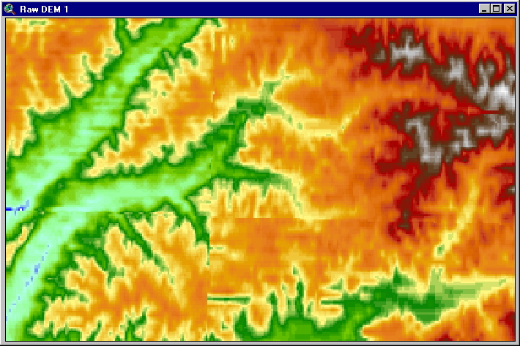The new window has a dedicated interface associated with it. At the menu bar, a menu labeled DEM is present. It contains two entries: Properties and Pre-Processing.
Selecting Properties from the menu displays in a pop-up window some of the DEM properties that were inferred when the importing took place. The option labeled Pre-Processing starts the preparation of the DEM for the channel network extraction.

Pre-Processing a DEM
The pre-processing of the DEM intends to eliminate areas where the determination of a flow path is hindered by local topographic features. Pits and depressions must be filled to the elevation of their local outlets. Flat areas are eliminated by imposing a relief that is based on the terrain form of the surrounding areas.
The model TOPAZ has sophisticated algorithms to eliminate these problems. For a complete description of the depression treatment algorithms, see Garbrecht and Martz, 1995. Through its GUI FRAME helps the user in selecting options and parameters for the pre-processing operations.

Aggregation and Re-sampling
TOPAZ provides two options in case the model will be used in computer systems with poor resources. If necessary, the user can reduce the amount of data by transforming the DEM into a coarser grid. These procedures reduce the accuracy of the DEM, and therefore the quality of the extracted channel network, and their use should be avoided. Aggregation is a linear averaging of elevations over a window of up to ten by ten DEM cells. Re-sampling extracts elevation values at regular intervals of rows and columns. The maximum interval value is 10.
When the Pre-Processing option is selected from the DEM menu, FRAME asks the user if aggregation or re-sampling is to be used.

Smoothing
TOPAZ allows the DEM to be smoothed before processing. This is accomplished by performing a weighted-average in a moving 3 by 3 cell window. The user can specify different weights for the central cell, the cross-cells and the diagonal cells. In addition, the smoothing procedure can be repeated several times by specifying the number of passes. FRAME inquires about this option before Pre-Processing starts. If smoothing is elected, FRAME provides a message box for the user to input the number of smoothing passes and the cell weights. The default values are one smoothing pass with equal weights for all cells.

Treatment of Depressions
TOPAZ’s depression analysis algorithm identifies and delineates all closed depressions in the DEM. It assumes all depressions are spurious and it essentially modifies the DEM by increasing elevations within a depression to a level where an outlet can be defined.
There are two approaches used in accomplishing the depression filling. According to user's choice, the depressions can be either entirely filled until the lowest depression outlet is found, or existing narrow blockages are breached, so that an outlet is created.
The first option models the natural formation of ponds. The water fills the depression until a certain elevation is reached. An outlet is found and the water reassumes its flow downstream. The second option assumes that as in nature depression features are often breached (valleys, gullies), but the breach is too narrow to be registered by the coarse resolution of the DEM. The breaching option avoids the filling of large areas, which can be the result of poor DEM definition due to its resolution or inherent errors.
If the user opts for breaching narrow depressions, the breaching length has to be specified to either one or two cell widths. The algorithm then modifies the elevation of a few selected cells to eliminate the depression.
The FRAME interface asks the user if the breaching procedure is to be applied, and what should be the breach length (either one or two cell lengths).

Treatment of Flat Areas
Flat areas inherent to the DEM and those created by depression filling are eliminated by increasing the cell elevation by very small increments. The TOPAZ algorithm assumes that these areas are not flat in nature, and they are the result of the low vertical resolution of the DEM, which is typically one foot or one meter.
The elevations within the flat area are inferred from the rising and falling terrain surrounding it. The purpose of this treatment is to eliminate ambiguity when defining flow lines across these areas. The flow is forced to take the shortest path, flowing away from rising terrain, towards the flat area outlet. This algorithm is always applied, and there are no options or calibration parameters.

Channel Network Extraction

Algorithms
The Channel Network Extraction algorithms of TOPAZ-DEDNM use only a DEM and two user-defined parameters to define all channels and subwatersheds. FRAME provides a convenient interface to guide the user in defining the parameters. FRAME also retrieves the necessary information about the DEM, reducing the amount of information the user has to input.
The process of channel network extraction is entirely based on the analysis of raster maps. First the DEM is scanned, and for each cell, the direction of the steepest downward slope to an adjacent cell is determined. The information is stored in another raster map. Then another algorithm determines the upstream drainage area for each of the raster cells. Starting at the DEM borders and cells that do not receive inflow from their neighbors, flow paths are traced and the drainage area for each cell is accumulated. The resulting raster already shows all the potential channels. However, most channels are very short and do not have upstream drainage area large enough to provide run-off to form a real, permanent channel.
Therefore, there is a need of specifying what the minimum drainage area to form a channel should be. This value is a function of soil characteristics, vegetation cover, terrain slope and climatic conditions. This minimum area value is called Critical Source Area (CSA), and must be defined by the user.
The numerical processing of the DEM can produce channels that are very short in length. They may represent valley indentations, and in most cases are gully outlets and other features not normally considered as part of a channel network. This threshold length of channels is called Minimum Source Channel Length (MSCL).
These two parameters control the appearance of the drainage network, and they can be used for calibration purposes. The same set of parameters should be applied to regions of uniform drainage properties. If the DEM covers an area with different drainage characteristics, the landscape must be subdivided into regions of similar properties. The user should provide a raster file the same size of the DEM, whose values identify the distinct regions.
Once the extraction parameters are known, the drainage area raster is reduced to reflect only the channels that meet the user-specified Critical Source Area and Minimum Source Channel Length.
FRAME then halts the channel extraction process. At this point, there is no definition of watersheds, only channels. FRAME displays a channel map, in which the user can immediately identify the watershed of interest and specify its outlet. This is done interactively, by clicking the desired point on the map. FRAME gets the coordinates of the selected point and proceeds to delineate the watershed.
Once the watershed boundaries are determined, all channels outside the watershed are removed. Then, junctions and channels are identified, and nodes are created at junctions and beginning of channels. All channels are classified using the Strahler ordering system.
With the channel network completely defined, the flow vector raster is used to identify all subwatersheds. FRAME extends TOPAZ-DEDNM by creating a relational database to store the channel network and subwatersheds data. This database eliminates the need of reference to the large, computer resource demanding, raster files.
For detailed description of all algorithms used in the channel network extraction process, please refer to Garbrecht and Martz, 1995.

Operation Control
Once a DEM is Pre-Processed and its image displayed on screen, the GUI provides a menu entitled Channel-Network that allows the user to specify the parameters for the extraction of a channel network and perform the extraction operation.
If more than one Processed DEM exists, the one currently selected will be used. A Processed DEM can be selected by simply clicking on its window.
Since most likely the user will try different combinations of parameters to extract the channel network, the procedure is divided into two steps. First, one or more sets of parameters are created. Second, the user chooses a particular set and performs the operation of channel extraction using the selected set. This allows for the use of the same parameter set for different DEMs or for DEMs pre-processed with different options, or the use of several sets of parameters applied to the same DEM.
To extract the channel network, the user selects one of the Processed DEMs, and specifies which parameter set to use.

Channel Network Extraction Parameter Sets
In order to manage the creation and editing of parameter sets, four options are provided. They are all called from the menu entry labeled Parameters, from the Channel-Network menu. The available operations are:
- Add a New Set
- Edit Existing Set
- Remove Existing Set
- View Existing Set

Adding a New Set
This option allows the user to create a new set of channel network extraction parameters. This set is stored internally, and is composed of data entered by the user. When a new set is created, the user is prompted for a name for this set. This name is to provide easy means of identification. The name can be any string, with a recommended length of no more than 30 characters.
When this option is selected, FRAME prompts the user for a series of parameters and options. FRAME allows for the creation of 10 sets, but removing existing sets does not allow for the creation of new ones.

Parameter Set Name
The user has the option to provide a name for the set of parameters. This is to help the user identify the set later. Any string is valid: characters and numbers can be entered in any combination. A maximum length is recommended, but not enforced. Longer strings will not show completely in the GUI. If no name is provided, a default name “Parameter Set #” is used, where # is a sequence number, incremented every time a new set is created. This number is not reused, even if a set is removed later.

Spatial Distribution of Parameters
The channel network extraction parameters can be specified as valid for the entire DEM (same parameters applied everywhere), or different parameters may be specified for different regions of the DEM, which must also be specified by the user. In the latter case, an auxiliary raster file denoting the regions with different parameters must be provided.
The user is prompted the following question, with two options to choose from:
“Network Extraction Parameters are:
- Spatially Constant;
- Spatially Varied”
The Spatially Constant option means that the two extraction parameters, Critical Source Area (CSA) and Minimum Source Channel Length (MSCL), are applied to the whole DEM.
If Spatially Varied is chosen, the user is prompted for the number of regions within the DEM that are to be processed with distinct parameters. The maximum number of regions is five. According to the number of regions, the user will be prompted to enter that number of pairs of CSA and MSCL values. Note that the user has to create and provide a raster file that matches the same number of regions entered here. The user is then asked for the type of the raster file and its name. The supported formats for this file are discussed in Appendix C.
Depending on the option for the spatial distribution of parameters, the user is prompted for one or more pairs of CSA and MSCL values. Default values appear in the respective fields for guidance purposes only.

Elimination of Lower-Order Channels
FRAME provides an additional option, which was not implemented in the TOPAZ-DEDNM module. The user can specify the minimum channel Strahler Order of channels to remain in the network. This option removes lower order channels after the channel network is extracted from the DEM. The distinction between using this option and selecting higher values for the extraction parameters is that lower-order channels are still considered when defining the subwatersheds. The number of subwatersheds is consistent with the original number of channels in the extracted network. Since often the flow in lower-order channels is relatively small, its routing by the channel flow model can be regarded as unnecessary, and will be carried out by the watershed model. In order to save computing time and resources, the user can remove some channels from the network. Note that the outflow of the subwatersheds corresponding to the removed channels is still considered as point inflows to the channel network.
The removal of lower-order channels is made by selecting the minimum Strahler order of channels to remain in the network. If 1 is chosen, no channels are removed. If 2 is the number selected from the GUI, first order channels will be eliminated and the lowest channel order in the network will be 2.

Editing an Existing Set
The Parameters menu entry provides the option of editing a set previously entered. If the option is selected, FRAME displays all current sets using their names for identification. The user can change any of its parameters or options, including modifying a Spatially Constant set into a Spatially Varied one, and vice-versa. This option can also be used to change the name of a set. The FRAME GUI shows the current values for a selected set. The user can simply enter a new value in the interface’s input boxes.

Removing an Existing Set
The user can discard any set by using this option. All sets are displayed, and the user can select one or more sets to be removed. Note that for the current version of FRAME, discarding sets does not reset the maximum number of parameter sets that can be created within a Project.

Viewing an Existing Set
This option displays all available sets, and after user selection, displays the contents of that particular parameter set in a window.

Channel Network Extraction
If at least one set of extraction parameters is already available, the entry Extract Channels in the Channel-Network menu becomes active. This option is used to perform the channel network extraction operation. Note that this menu appears only when a Processed DEM is selected.
When this option is activated, FRAME asks the user to select which parameter set to use for the channel extraction. Note that the DEM is selected by clicking in its window, or by selecting it from the Project window, under the icon DEMs. The DEM from which the channel network will be extracted is the one activated by any of these two means of selection.
FRAME then calls the Channel Network Extraction program to process the DEM and define the channels. When the operation is complete, FRAME displays the channel network in its raster form. In this window, the user should identify the watershed outlet to continue the process of watershed delineation. The displayed network comprises all the channels that met the conditions imposed by the extraction parameters CSA and MSCL. When a point in the network is selected, a new processing step begins. The watershed must be defined, and all channels that do not belong to the watershed are removed.
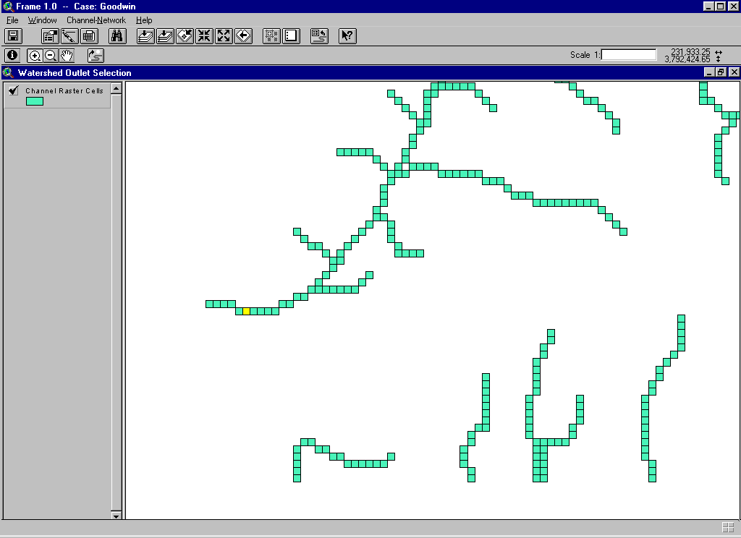

Watershed Delineation
As soon as the process of channel extraction is completed, FRAME displays the whole network on screen, in a window called Watershed Outlet Selection. The network spans the whole DEM, and its channels usually belong to more than one watershed. The user must specify the outlet of the watershed of interest, by clicking with the mouse in one of the channel raster cells. The interface provides tools for panning and zooming to facilitate the selection of the outlet point. When the watershed outlet is selected and confirmed, the Watershed Outlet Selection window disappears, and FRAME continues the process to perform the following tasks:
- Delineate the watershed based on its selected outlet;
- Remove all channels that do not belong to the watershed of interest;
- Define all channels and subwatersheds within the watershed of interest;
- Eliminate lower-order channels, if so required;
- Define nodes at beginning of channels, junctions and points of inflow where channels were removed;
- Define the connectivity among nodes, channel links, and subwatersheds;
- Create and export the FRAME Network Database;
- Create and export auxiliary images, tables, etc.
A new window entitled Extracted Channel Network displays the channels and nodes of the drainage basin corresponding to the selected outlet point. Nodes are classified according to their function. FRAME identifies the several node types using different symbols. FRAME allows the user to change some of these symbols.
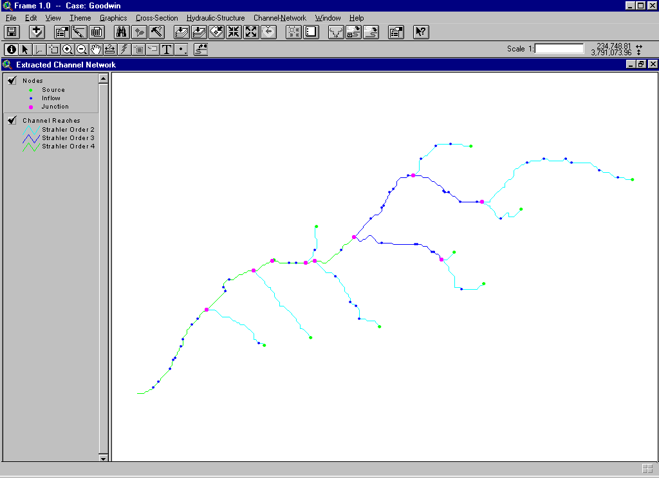As part of the channel network extraction process, two auxiliary maps are created, and stored within the Project. The Flow Path map shows the direction of flow for each raster cell. The Channel Raster Cells map contains all cells that compose the channels within the watershed, regardless of the eventual removal of lower-order channels. These maps are not automatically displayed on screen. They can be opened from the Project window, under the icon Rasters
The Watershed Outlet Selection window remains in the Project, under the icon Channels. It can be used to modify the position of the watershed outlet, for the same extracted network.
The process of channel network extraction culminates with the creation of a relational database containing the necessary information for the subsequent tasks of FRAME. This database is referred hereafter as the FRAME Network Database.

Frame Network Database

Introduction
TOPAZ-DEDNM, the module responsible for the pre-processing of DEMs, channel extraction, and watershed delineation, consists of a series of algorithms applied to data sets stored in raster format. These rasters are large arrays containing integer values that represent a certain characteristic for each quadrilateral cell. This method is very efficient when the information is continuous, such as a DEM, where for each cell there is a known elevation value. When it comes to a channel network, for example, the number of cells necessary to represent the channels is rather small compared to the total dimension of the raster array. Besides, a raster array cannot easily store logical information, such as for example the connectivity between nodes and channel reaches. For these reasons, once the channel extraction procedure is finished, all the relevant information is converted into a relational database. This database is composed of many tables that store data related to a certain entity. The Node table, for example, stores the node coordinates, the relationship among nodes, and a series of indices that relates this table to other tables in the database, hence the denomination “relational.” This model of storage provides an efficient method to retrieve and correlate information, and reduces the amount of storage requirements.
The creation of this database is made within the channel extraction module, for computational efficiency. The database consists of a series of six tables, which describe the channel network and the corresponding subwatersheds.
The design of the database allows more tables to be added to describe information not yet available at the moment of its creation. Channel cross section data and hydraulic structure data, such as for culverts and drop structures, are good examples.
As output from the channel network extraction and watershed delineation process, six relational tables are created to logically represent the channel network, the subwatersheds, and all the pertinent data.

Channel Network Logical Organization

Nodes and Channel Segments
The channel network is logically organized into the following entities: “Nodes”, “Reaches”, “Links”, and “Channels.”
A Node is a point in the network that represents a special feature. They mark beginning and end of channel segments, the location of channel junctions, point inflow, and hydraulic structures. They may also represent points in a computational mesh that represents the channel network, where flow and sediment transport variables will be computed.
The remaining entities indicate segments of channel. A Reach is any channel segment between two nodes. Logically, each Reach has a Node at each end. It has properties such as length and slope, and has also a graphical representation: a line segment used in constructing the network maps.
A Link is a logical entity, whose main purpose is to organize the numerical computation of flow in the network. A link can assume two types: a container of Reaches or a single hydraulic structure. A Link is usually composed of several channel Reaches. It can also be identified by the nodes at each end, and has properties such as length and slope. Thus, a Link is defined as a segment of channel that either:
- starts at a Source Node, i.e., a node at the point where a channel begins, and ends at a Channel Junction, i.e., the confluence of two channels;
- starts and ends at Channel Junctions;
- starts at a Source Node and ends at the point where a Hydraulic Structure is located;
- starts at the point of a Hydraulic Structure, and ends at a confluence.
The Link also represents the special case of hydraulic structures in the channel network. Each structure is a Link by itself. This special Link has no Reaches, and the node at its upstream end is the same as that at its downstream end.
The entity Channel also contains reaches. Channels either:
- start at a Source Node, i.e., a node at the point where a channel begins, and end at a Channel Junction, i.e., the confluence of two channels;
- start and end at Channel Junctions.
A Channel represents the natural division of the network into channels. The presence of hydraulic structures does not affect its logical definition. When the channel network is extracted from a DEM, Channels and Links are identical. Only when hydraulic structures are added to the network they will differ.
This organization could be easily hidden from the common user. Only nodes and reaches have “visible” representations that are displayed in maps. Links are of concern only for the modeler, since the presence of hydraulic structures determines special precautions and methods. Links determine the routing order of the channels in the flow and sediment routing models.

Subwatersheds and Incremental Areas
The definition of subwatersheds is performed by TOPAZ-DEDNM, which identifies the drainage area for each channel segment in the network. Subwatersheds should correspond to the segments called Channel, as defined above. However, the extracted network may have its lower-order channels removed. The removal of channels does not affect the definition of the subwatersheds, so there will be more subwatersheds than Channels. The difference is exactly the number of channels that were removed from the network. The removal of channels creates additional nodes in the network. They represent the drainage area of the subwatershed associated with the removed channel. The nodes provide a location where the outflow of this subwatershed is to be taken into account during the flow and sediment transport simulations.
FRAME divides the subwatersheds into portions called Incremental Areas. Incremental Areas are drainage areas that correspond to Reaches, the segments of channel between two nodes. The purpose of incremental areas is basically computational. They provide easy means of subdividing the outflow from a subwatershed among all nodes of its channel. When the network is extracted from a DEM, Incremental Areas coincide with the Subwatersheds, except for first Strahler order channels. First order channels have two incremental areas, one that encompasses the region that drains into the node at the beginning of the channel (the Source node), and a second area that represents the drainage downstream of that point, down to the node at the subwatershed outlet.

Node Numbering Scheme
FRAME uses the node numbering algorithm present in TOPAZ-DEDNM to create its own numbering system, which is better suited to the flow and sediment transport simulations.
TOPAZ-DEDNM assigns node numbers after all links are defined. The watershed outlet node, which was assigned by the user, is assigned node number one. The channel network is traced upstream from this point, following always the left-hand branch at each node. When the source node is encountered, the algorithm back-traces until the previous junction and follows the branch not previously evaluated.
FRAME reverses the procedure, so that the node numbers increase in the downstream direction. In addition, before the FRAME node numbering system is applied, lower-order channels are removed from the network according to user option.
The new algorithm for node numbering uses the information created by the original TOPAZ-DEDNM algorithm for computational efficiency. In the new scheme the network is traced upstream from the watershed outlet until a channel junction is found, then following the right-hand channel to its source node, always selecting the right-hand channel. The algorithm then descends that channel, assigning incrementing node numbers, until the first channel junction is reached. Then the procedure is repeated for the second, left-hand channel.
In this scheme, the source node of the right-hand channel closest to the outlet is assigned node number one. The watershed outlet has the highest node number. Note that if the order of a channel is lower than the user-specified minimum order of channels that are to remain in the network, the channel is ignored and skipped. Junctions where one of the channels is marked for removal become simple nodes, which are accounted for in the numbering algorithm, and receive a special code to identify its type. They are called Inflow Nodes.
The algorithm continues the trace upstream, always numbering the nodes in the right-hand channels first. When, at a junction, both incoming channels were already inspected and the nodes numbered, the nodes in the channel downstream of this junction are numbered.
This numbering system suits well the numerical scheme used in the flow model. The computation simply follows the nodes according to their numbers. Since a type is assigned to each node by the numbering algorithm, the beginning and ending of the FRAME Links and Channels is readily determined.

FRAME Channel Junctions
There are important differences in the treatment of channel junctions, compared with the original TOPAZ-DEDNM algorithm. A channel junction in the FRAME network is always made of two incoming channels and one outgoing channel. Drainage networks extracted from DEMs commonly have more than two incoming channels, up to the theoretical maximum of seven. FRAME treats these cases as a series of consecutive channel junctions, each having two incoming and one outgoing channels. Furthermore, a FRAME junction is in fact composed of three nodes, all at the exact same location: one node at the end of each incoming channel, and a node at the beginning of the outgoing channel. This approach of multiple nodes helps the numerical implementation of the discretization and solution methods of the flow and sediment transport models.
The incoming channels always terminate at a node, which receives a code and the denomination End of Link Node. The node at the upstream end of the outgoing channel is called a Junction Node.
Note, however, the following special cases:
- Suppose that three channels converge to the same location. Ordinarily FRAME would create two channel junctions in sequence, with two channels entering each junction. However, if two of these channels are of low order and are to be removed from the network, the junctions are no longer necessary. FRAME creates a single Inflow node at that location. The subwatersheds corresponding to the removed channels both discharge at this new node.
- Suppose that at this same multiple junction, only one channel is to be removed. The result would be a complete junction (with its three nodes) and an extra Inflow node at the same location. FRAME inspects the network for cases like this and simplifies the problem by eliminating the Inflow node and assigning as outlet the node at the end of the incoming channel that is the closest to the removed channel.

FRAME Links and their Computational Sequence
The node numbering scheme adopted by FRAME makes sure that nodes and links are ordered according to the needs of the simulation models. FRAME determines its Links and Channels by inspecting the network following the nodes in ascending order of their FRAME numbers and checking for the node type codes assigned during the numbering process. Each Link receives a computational sequence index. This index naturally follows the node numbering, since nodes were ordered according to the needed computational sequence.

FRAME/SWAT Subwatersheds
Similarly to the nodes and channel links, TOPAZ-DEDNM identifies and defines numbers for subwatersheds. TOPAZ-DEDNM separates the areas draining into the source nodes, and the right and left banks of the channel links. FRAME groups these areas into one, which represents the drainage area of that channel segment.
FRAME uses the same numbering system used in the watershed program SWAT, (Arnold et al., 1993). Subwatershed number one discharges at the watershed outlet, and the remaining subwatersheds are numbered by tracing the drainage network upstream and taking always the left-hand channel when a junction is found.
The outflow of each subwatershed is assigned to a node in the channel network. Nodes of type Junction do not receive inflow from subwatersheds. They are routed to the nodes of type End of Link, at the same location.

Database Tables
The watershed and the channel network are described by six tables of a relational database. These tables contain all the information necessary for all tasks supported by FRAME.
Database tables are composed of Fields and Records. A Field is a certain property of the entity represented by the Table. A record identifies a certain instance of that entity, and it is a collection of all Field values.
A record in a table is related to a certain record in another table by means of an identifying index, or ID. IDs are unique within a table. In the FRAME database, if a record is added to a table, it receives an ID number that is the current greatest ID plus one. If a record is removed, its ID number is discarded, but it is not made available for reuse. ID's sole purpose is as an identifying number for records. They are not related to any property in particular. Note that the highest ID number does not necessarily agree with the number of records in the table. If many add and remove operations are performed on a table, the ID number, which always starts at 1, can be much larger than the number of records in the table.
The FRAME database was designed in such a way that operations that are performed frequently, such as the addition of a node to the channel network, for example, can be performed quickly, with a minimum of modifications to the table.
The Node Table assumes a greater importance in the database. Since the modeling components of FRAME are node-oriented, the database assumes a form that is convenient for most operations of data retrieval and record updating. The Node Table stores the basic properties of a node, those that are common to all nodes. Supplemental information is stored in separate tables. The Node Table stores indices (or IDs) for retrieval of information from the other tables. For example, channel cross-sectional information is stored in a separate table. For each Node record, an index identifies the corresponding record in the Cross Section table. Similarly, other tables use indices to relate to the Node Table. This allows for an easy expansion of the database in case new functionality is added to FRAME. New tables can be created, the only modification to the existing database being the inclusion of a field in the node table to store a new index.
There is also an auxiliary table called Raster. This table stores the information about the raster cells that compose the channel network as extracted from the DEM. It is used primarily for visualization, and during the process of channel extraction, to select of a point as the watershed outlet.
Some tables are created with fields that are not immediately applicable to a channel network as extracted from a DEM, but that will be later used to store additional information.

The Node Table
The Node Table is part of a shapefile, the file format used by ArcView that in reality consists of three separate files:
- The shape file (extension .shp) contains the graphical representation.
- The table file (extension .dbf) contains the attributes as described below
- The index file (extension .shx).
The Node Table can be represented by the following “schema”:
Table Node ND ( ND_ID, ND_FRMNO, ND_TYPE, ND_XC, ND_YC, ND_DSID, ND_USID, ND_US2ID, ND_CSID, ND_RSID, ND_STID )

ND_ID – Node Identification Number (ID)
This number identifies the node record. The ID number is the reference used in all the database operations, such as joining or linking of tables, searches, etc. The ID number is given when the record is added to the table, and remains unchanged. This is not the node number used in the computational mesh.
ND_FRMNO – FRAME Node Number
This field contains the FRAME Node Number. Nodes are numbered in the sequence of numerical computation. The node numbering changes when a new node is added to the channel network, so this field is often updated.
ND_TYPE – Node Type
Identifies the type of node, according to its origin, position, or function. For a channel network extracted from a DEM, the following node types exist:
Node Type | Code | Description
Source Node | 0 | Identifies the beginning of a channel.
Inflow Node | 1 | Represents the inflow corresponding to a channel removed from the network after extraction from a DEM
Junction Node | 2 | Represents a confluence of two channels.
End of Link | 3 | Marks the end of a channel link.
The Inflow node replaces former junctions that disappeared when lower-order channels were eliminated. This node is used to receive the outflow from one or more subwatersheds that correspond to the removed channel(s).
ND_XC – X-Coordinate - East-West
A coordinate value on the East-West axis, representing the node position.
ND_YC – Y-Coordinate - North-South
A coordinate value on the North-South axis, representing the node position.
ND_DSID – Next Downstream Node ID
This field stores the ID number of the node immediately downstream of the current node.
ND_USID – Next Upstream Node ID (trivial case)
This field stores the ID number of the node immediately upstream the current node.
ND_US2ID – Next Upstream Node ID (channel junctions)
For junction nodes, there are two possible paths when navigating the channel network in the upstream direction. This field stores the ID number of the second immediately upstream node. For all other node types, the “No Data” value, -1, is stored in this field.
ND_CSID – Cross Section Record ID
This is the Identification Number (ID) of a record in the Cross Section Database Table (CS) that corresponds to the current node record. This field will be used later, when the channel cross section data becomes available. At the moment of the channel network extraction, all records have the “No Data” value in this field.
ND_RSID – Raster Cell Record ID
This is the Identification Number (ID) of a record in the Raster Cell Database Table (RS) that corresponds to the current node record.
ND_STID – Hydraulic Structure Record ID
This field stores the Identification Number (ID) of a record in the Hydraulic Structures Database Table (ST). When hydraulic structures are added to the database, this field will correlate a Structure node to its corresponding entry in the ST table. After extraction from the DEM, all nodes have “No Data” as value for this field.

The Reach Table
The Reach Table is also a part of a shapefile, and contains the following fields:
Table Reach RC ( RC_ID, RC_NDUSID, RC_NDDSID, RC_ORDER, RC_LENGTH, RC_SLOPE, RC_NUMPTS )
RC_ID – Reach Identification Number (ID)
This field contains the ID for a Reach in the channel network.
RC_NDUSID – Upstream End Node ID
This is the ID number of the node at the upstream end of a Reach.
RC_NDDSID – Downstream End Node ID
This is the ID number of the node at the downstream end of a Reach.
RC_ORDER – Reach Strahler Order
Contains the Strahler order of the channel Reach.
RC_SLOPE – Bed Slope
Contains the bed slope of the channel Reach.
RC_LENGTH – Reach Length
Contains the length of the channel Reach.
RC_NUMPTS – Number of Points in Line
This field contains the number of points with known coordinates that define the graphical representation of the line representing the channel Reach. The coordinates themselves are stored in the .shp file.

The Link Table
The Link Table does not have a graphical representation. It is used to logically assemble the nodes and reaches that form the channel network. The fields in the Link table are:
Table Link LK ( LK_ID, LK_CMPSEQ, LK_NDUSID, LK_NDDSID, LK_RCUSID, LK_RCDSID, LK_TYPE, LK_LENGTH )

LK_ID – Link Identification Number (ID)
LK_CMPSEQ – Link Computational Sequence
Stores an index that indicates the position of the link in the computational sequence of the numerical computations for the channel network.
LK_NDUSID – Upstream End Node ID
Stores the ID of the node at the upstream end of the Link.
LK_NDDSID – Downstream End Node ID
Stores the ID of the node at the downstream end of the Link.
LK_RCUSID – Upstream End Reach ID
Stores the ID of the first Reach in the Link (upstream end).
LK_RCDSID – Downstream End Reach ID
Stores the ID of the last Reach in the Link (downstream end).
LK_TYPE – Link Type
Stores a numeric code indicating the type of Link.
Link Type | Code | Description
Channel | 1 | The Link is an ordinary channel segment.
Hydraulic Structure | 2 | The link represents a hydraulic structure in the channel network.
All Links are of type 1 – Channel – after the extraction of the network from a DEM.
LK_LENGTH – Link Length
Contains the total length of the channel Link.

The Channel Table
The Channel Table is an auxiliary table that helps in the definition of the channel network topology. When there are no hydraulic structures in the network, Channels are equivalent to Links. The Channel table represents the network as it was extracted from the DEM, and it is invariable.
The Channel table has the schema:
Table Channel CH ( CH_ID, CH_NDUSID, CH_NDDSID, CH_LENGTH )

CH_ID – Channel Identification Number (ID)
CH_NDUSID – Upstream End Node ID
CH_NDDSID – Downstream End Node ID
CH_LENGTH – Channel Length

The Subwatershed Table
The Subwatershed Table gathers all the data about the subwatersheds, as extracted from the Digital Elevation Model. It has the following schema:
Table Subwatershed SW ( SW_ID, SW_SWATNO, SW_NDUSID, SW_HASCHN, SW_NUMIAS, SW_CHLGTH, SW_DRAREA )

SW_ID – Subwatershed Identification Number (ID)
SW_SWATNO – Subwatershed Number
Contains the watershed number as defined by the Watershed Model SWAT.
SW_NDUSID – Channel Upstream End Node ID
Stores the node at the upstream end of the channel that traverses the subwatershed.
SW_NDDSID – Downstream End Node ID
Stores the node at the watershed outlet. If the subwatershed has a channel in the network, this node is at the downstream end of the channel. If the subwatershed corresponds to a low order channel that was removed from the network, the node stored here is the former channel confluence (the original outlet for the watershed), which is now a node of type Inflow.
SW_HASCHN – Subwatershed Has Channel Flag
This field stores a numeric code that indicates if the subwatershed has a corresponding channel in the network or if the channel was previously removed.
Code | Description
1 | Has a Channel in Network
2 | Has Not (channel removed)
SW_NUMIAS – Number of Incremental Areas
This field contains the number of Incremental Areas within the Subwatershed.
SW_CHLGTH – Subwatershed Channel Length
Stores the total length of the channel contained in the subwatershed.
SW_DRAREA – Subwatershed Drainage Area
Contains the drainage area of the subwatershed

The Incremental Area Table
The Incremental Area Table has the following fields:
Table Incremental Area IA ( IA_ID, IA_SWID, IA_POSIDX, IA_NDDSID, IA_CHLGTH, IA_DRAREA )

IA_ID – Incremental Area Identification Number (ID)
IA_SWID – Subwatershed ID Number
Stores the ID of the Subwatershed to which the Incremental Area belongs.
IA_POSIDX – Incremental Area Position Index
Stores an index indicating the relative position of the Incremental Area within the Subwatershed. A value of 1 (one) indicates that the Incremental Area lies at the downstream end of the subwatershed. The index increases in the upstream direction. Subwatersheds of source channels have two incremental areas, the upstream area (index 2) representing the drainage area of the source node itself, and the downstream area representing the drainage along the channel.
IA_NDDSID – Downstream end node ID
Contains the ID of the node at the outlet of the Incremental Area.
IA_CHLGTH – Incremental Area Channel Length
Stores the total length of the channel contained in the Incremental Area.
IA_DRAREA – Incremental Area Drainage Area
Contains the drainage area of the Incremental Area.

The Raster Table
The Raster Table stores information about the Raster Cells that compose the channel network, as defined by the Channel Network Extraction program TOPAZ-DEDNM.
The fields of this table are:
Table Raster RS ( RS_ID, RS_ROW, RS_COL, RS_XC, RS_YC, RS_Z, RS_FLV, RS_ACCA, RS_DSID )
RS_ID – Raster Cell Identification Number (ID)
RS_ROW – Raster Cell Row Index
RS_COL – Raster Cell Column Index
RS_XC – X-Coordinate - East-West
A coordinate value on the East-West axis, representing the node position.
RS_YC – Y-Coordinate - North-South
A coordinate value on the North-South axis, representing the node position.
RS_Z – Raster Cell Elevation
RS_FLV – Raster Cell Flow Vector Code
The Flow Vector code indicates the direction of flow within a raster cell, as determined by the channel network extraction algorithm.
Code | Flow Direction
1 | Northwest
2 | North
3 | Northeast
4 | West
5 | Indeterminate
6 | East
7 | Southwest
8 | South
9 | Southeast
RS_ACCA – Raster Cell Accumulated Drainage Area
Contains the total drainage area upslope of the current cell.
RS_DSID – Immediately Downstream Raster Cell ID
Contains the ID number of the immediately downstream channel cell.

The Flow Direction Table
The Flow Direction Table stores information about the Raster Cells that compose the subwatershed. They are used for visualization only.
The fields of this table are:
Table Flow Direction (Vector) FV ( FV_ID, FV_FLDIR, FV_SWATNO )

FV_ID – Raster Cell Identification Number (ID)
FV_FLDIR – Flow Direction Code
Stores the same codes as described in the Flow Vector Field of the Raster Table.
FV_SWATNO – The SWAT Subwatershed Number
Stores the number of the SWAT subwatershed to which the raster cells belong.

Program Control

Importing and Pre-Processing DEMs
In order to facilitate the use of the DEM processing module, FRAME reduces the user interaction to simply specifying the DEM file and the required options and parameters. When a DEM is imported, FRAME starts to gather the information needed to perform the channel network extraction. For each imported DEM, the following data are read or computed, and stored internally:
- File type and name.
- Number of rows and columns.
- DEM cell size.
- DEM boundary coordinates.
- Value for undetermined elevations.
- DEM maximum and minimum elevations.
Within FRAME, each imported (Raw) DEM has a View with a color image denoting the original elevation values. Each DEM appears in the list of documents, when the icon DEMs is active in the program window. Internally, the data for a DEM is associated with the DEM View. If more than one DEM is imported, they are automatically numbered sequentially, e.g. “Raw DEM 1” and “Raw DEM 2.”
The Pre-Processing options and parameters are also stored internally. They are linked with a View showing the color image of the modified (Processed) DEM. If the Pre-Processing is performed successfully, the image is automatically created and a new document name appears under the DEMs icon in the Project window, as for example, “Processed DEM 1.”
After the Pre-Processing parameters are entered, FRAME stores data read from the DEM, internally computed data (coordinates, maximum and minimum elevations), and data input by the user to a special file on disk. This file is read by the Channel Network Extraction program frmxtr, and is documented in Appendix C. After the file is written to disk, FRAME calls frmxtr to perform the Pre-Processing operations. The new, treated DEM is converted into a TIFF image and displayed.
For any DEM, the menu entry Properties displays the internally stored information. If the DEM was already processed, the user can verify the parameters used for aggregation/re-sampling, smoothing, and depression filling options.

Extracting the Channel Network
When a window containing an already Processed DEM is active, the main menu bar contains a menu labeled Channel-Network. This menu has two entries: Parameters and Extract Channels. The entry Parameters displays a message box from which the user can choose the type of operation to be performed in an internal database that manages the sets of parameters and options. The available options were introduced in section 3.3.3 Channel Network Extraction Parameter Sets. The user has access to the data structure only through these options. All data are saved automatically within the Project.
When at least one set of parameters was entered through the interface, the option Extract Channels is enabled. The user is then asked to select which set of parameters should be used by the network extraction algorithms. Then FRAME retrieves all the parameters from the internal database, and writes a file to disk containing DEM information and the retrieved parameters. This file is documented in Appendix C. After the writing of the file, FRAME starts the Channel Network Extraction program frmxtr.
frmxtr will analyze the DEM, define all channels, and save the necessary information to disk, for later use. It outputs the channels in a graphical form, which is imported into the Project.
A new window appears, entitled Watershed Outlet Selection. This window has a special GUI. The interface has zoom and pan tools. The user can zoom in on or pan to a particular region. A special button must be activated to specify the point of the watershed outlet. When the user clicks at a point and commands confirmation, FRAME transforms the coordinates of that point into row and column indices in the DEM raster. This information is added to the internal database of channel extraction parameters.
The file containing the extraction parameters is updated to contain the row and column user-specified watershed outlet raster cell. The extraction program frmxtr is restarted to delineate the subwatersheds and create the FRAME Network Database, as described in section 3.4 FRAME Network Database.
When frmxtr exits, FRAME automatically uploads the results into the Project. All database tables are read in and stored in the Project, under the icon Database. All tables are identified by the name Extracted Channel Network: followed by the name of the table.
FRAME also creates a map of the channel network containing all channel reaches and nodes. All nodes have symbols and colors according to their type. The interface provides means to the user to modify the symbols, if desired.
FRAME also creates an image showing subwatersheds the by converting the Subwatershed raster file created during the watershed delineation process into a TIFF image. This conversion takes place within the program frmxtr. FRAME assigns random colors to help identify each subwatershed. Contrarily to the Nodes and Channel Reaches images, which are vector files associated with the corresponding database tables, the Subwatershed is a raster image. There is no user action supported for this image.
The channel network map window, entitled Extracted Channel Network also has a dedicated GUI. The GUI allows the user to manage the input of channel cross section and hydraulic structure data, and proceed to the Channel Network Analysis phase, to create a computational mesh.
The publication “FRAME – Program Design and Implementation” discusses data storage and program flow control in detail.

Input And Output Files

Digital Elevation Models
FRAME supports the following formats for DEM files:
- ASCII Array
- ArcInfo ASCII Raster
- GRASS ASCII Raster
Please refer to Appendix C for explanations on how to create these files and a description of their formats.
FRAME automatically converts a DEM file into a TIFF monochromatic image for displaying. The TIFF image is saved using the following naming convention:
Case Name + _rawdem_ + Raw DEM Window Number + .tif
In order to reference the TIFF file in a map window, coordinates of the DEM boundaries are stored in a file in TIFF-World format with the same name but with extension .tfw. In addition, a log file is created using the same naming convention, but with extension .tlg.

DEM Pre-Processing

Module Communication File
The Pre-Processing instructions are stored into an ASCII formatted file, which is read by the Channel Network Extraction Program frmxtr. This file is later overwritten to store the options for the channel network extraction and subwatershed delineation. This file is named using the convention:
Case Name + _xtrinp + .txt
For a description of this file, see Appendix C.

Raster Files
The Pre-Processing algorithms create several raster files used to store information for the channel extraction step. They are named using the following convention:
Case Name + “_Content-String” + .out.
The Content-Strings identify the following raster files:
- inelev – Contains DEM elevation values. Can be either the original, or the re-sampled or aggregated values, depending on user choice.
- smooth – Contains the elevation values after the smoothing algorithm is applied.
- fildep – Contains the elevation values after the depression filling algorithm is applied.
- relief – Contains the elevation values after the flat areas removal algorithm is applied. These are the elevations values used in the channel network extraction processes and displayed by FRAME in a map window.
For a complete description of these files, see the TOPAZ-DEDNM documentation.

Image Files
After Pre-Processing, the DEM elevation values are converted into a TIFF image file named:
Case Name + _relief + .tif.
A corresponding World file has the same name, but extension .tfw.

Channel Network Extraction

Extraction Parameters Distribution Raster
If the user determines that the parameters for the Channel Network Extraction are spatially varied, a raster file of the same size of the DEM must be provided. The file should contain integer values between 1 and 5, denoting the various regions for each set of parameters entered through the user interface.
The raster files can be in the following formats:
- ASCII Array
- ArcInfo ASCII Raster
- GRASS ASCII Raster
See Appendix C for descriptions of these file formats.

TOPAZ-DEDNM Output Files
The procedure of extraction of the channel network creates several files that store data for later use, for the creation of the FRAME Network Database and for displaying purposes. The module communication file is the same used during the Pre-Processing stage.
TOPAZ-DEDNM creates the following raster files that are needed in the several steps of extraction process. Please See the TOPAZ-DEDNM documentation for information on these files. The following convention is used:
Case Name + “_Content-String” + .out.
- flovec – Contains the Cell Flow Direction values;
- uparea – Contains the Cell Accumulated Drainage Area;
- netful – Contains the drainage network definition for the whole DEM.

Watershed Delineation
The channel network and watershed delineation step creates a series of files to store pertinent information, reports and images. This step also creates the FRAME Network Database.

TOPAZ-DEDNM Output Files

Raster Files
TOPAZ-DEDNM creates the following raster files that are named with the convention
Case Name + “_Content-String” + .out.
- bound – Contains the outline of the watershed above the user-specified outlet cell.
- subwta – Contains the definition of the subwatersheds;
- netw – Contains the drainage network definition and channel Strahler orders for the watershed.

Table Files
TOPAZ-DEDNM creates the following files:
Case Name + _netw.tab – A text file containing a summary of the channel data, as defined by TOPAZ-DEDNM.
Case Name + _sbwt.tab – A text file containing information about the subwatersheds, as defined by TOPAZ-DEDNM

FRAME Network Database
The Channel Extraction and Watershed Delineation Module creates the FRAME Network Database. These files are described in section 3.4.7 Database Tables. They are named following the convention:
Case Name + “_Table Name” + “Extension”.
The Table Names, with the respective extension(s), are:
- node (dbf, shp, shx)
- reach (dbf, shp, shx)
- link (dbf)
- chann (dbf)
- subwt (dbf)
- incar (dbf)
- raster (dbf, shp, shx)
- fldir (dbf)

The extensions are:
- dbf – Database File
- shp – Shape (graphics) file
- shx – Index file

Channel Network Analysis

Introduction
FRAME provides many features to help the user prepare the input data for the flow routing and sediment transport simulations. The input data for the simulation models can be classified into three categories:
- Channel Network Definition – Describes the channel network elements, such as channel segments, nodes, location of hydraulic structures, subwatersheds, etc.
- Supplemental Data – Includes all the data that are not a part of the channel network description, such as channel geometry data, hydraulic structures characteristics, bed and bank material description, etc.
- Simulation Parameters – Comprises user-defined options and parameters for the numerical simulations.
FRAME is able to automatically create the channel network and the corresponding subwatersheds. It also creates a logical description of all the network elements and their mutual relationships. The simulation models, however, usually require a more detailed topological schematization of the simulation domain. This spatial discretization depends on characteristics of the numerical analysis methods. For the flow simulation, the channel network is represented by one-dimensional channel segments and by nodal points. The simulation models impose certain conditions for the number, size, and distribution of these elements. FRAME is designed to automatically define a computational mesh that adequately describes the channel network, ensuring that the numerical simulation will meet the minimum requirements of accuracy and stability.
When a channel network is created, it has already defined all the channel segments and some nodal points. The nodal points represent special features in the network, such as channel junctions, points of inflow, structure locations, etc. For the numerical analysis, however, a greater number of nodal points are necessary to adequately describe the characteristics of the simulation domain. FRAME provides capabilities for the addition of nodal points to the channel network. FRAME performs an analysis of the network layout and selectively adds nodal points to improve the computational mesh characteristics. This analysis considers the length of channel segments, the positioning of hydraulic structures, and channel cross section properties. Therefore, to begin the channel network analysis, cross section and hydraulic structure data must be available.
FRAME provides a convenient interface for entering, editing, checking, and visualizing the input data. FRAME tries to minimize the input work by performing some tasks automatically.

Cross Section Data Management

Cross Section Data
Cross section data here refers to three different data sets defining i) the geometrical shape of the channel and floodplains, ii) the bed material characteristics of the main channel and floodplains, and iii) properties of the sediment found in the channel banks. FRAME establishes similar procedures for data entry, editing, interpolation and visualization, that are applied to the three data categories.

Flow Model Requirements
The flow routing model requires that the channel cross section geometry be known for all computational nodes. FRAME relaxes this requirement by providing means of linear interpolation to supply the necessary information. The user is then required to supply cross section geometry data only for the nodes at beginning and ending of “Channels”, that is, for all Source Nodes and Channel Junctions. FRAME requires that cross section data for junctions and source nodes be available, before proceeding to the input of hydraulic structure data and the generation of the computational network. FRAME will automatically interpolate the cross section data for existing nodes in the middle of channels, thus reducing the required amount of data input. Note that FRAME will use interpolation only for nodes that do not have user-supplied information.
Bed and bank sediment material requirements are similar to those for the cross section geometry, as explained above. When specifying sediment data, only nodes at the beginning and end of “Channels” are required. Interpolation is used for the remaining nodes.
FRAME implements the cross section description format of the simulation models DWAVNET and BEAMS. Each cross section is represented by eight pairs of distance and elevation coordinates. The cross section is subdivided into three regions: main channel, left floodplain and right floodplain. The floodplain regions are optional. Each cross section is described by a local coordinate system (w,z). A distance w, sometimes called station, is given from an arbitrary origin at the left bank. All distances are given with respect to this origin. The cross section is assumed normal to the flow direction. All elevation values z must have the same reference datum. This datum may differ from the elevation datum used by the Digital Elevation Model.

Cross Section Geometry Database Table
When cross section data are supplied by the user, FRAME creates a new database table and appends it to the FRAME Network Database. FRAME establishes the logic connection between each cross section entry and its corresponding node. For each record added to the cross section table, FRAME stores its ID in the corresponding record in the node table. The node table has the field ND_CSID to store the ID values of the cross section description records.
The Cross Section Table also stores roughness values. For each subsection in the cross section, separate values of the Manning’s roughness coefficients must be entered. The database table has the following fields:
Cross Section Table CS ( CS_ID, CS_ORIGIN, CS_P1W, CS_P1Z, CS_P2W, CS_P2Z, CS_P3W, CS_P3Z, CS_P4W, CS_P4Z, CS_P5W, CS_P5Z, CS_P6W, CS_P6Z, CS_P7W, CS_P7Z, CS_P8W, CS_P8Z, CS_RGHMC, CS_RGHLF, CS_RGHRF, CS_TYPE)
The fields are:
CS_ID – Cross Section Identification Number (ID)
CS_ORIGIN – Cross Section Origin Code
Contains a string identifying the origin of the cross section data. The valid values for this field are:
- USERSPEC – The data were entered by the user
- INTERPOL – The data were linearly interpolated by FRAME, from the closest cross sections with user-specified data
- GENERATED – The cross section data were automatically generated by FRAME, based on channel and drainage characteristics. This option is not implemented in the current version.
CS_P1W – Point 1 - Left Valley Coordinate
CS_P1Z – Point 1 - Left Valley Elevation
CS_P2W – Point 2 - Left Floodplain Bank Toe Coordinate
CS_P2Z – Point 2 - Left Floodplain Bank Toe Elevation
CS_P3W – Point 3 - Left Bank Top Coordinate
CS_P3Z – Point 3 - Left Bank Top Elevation
CS_P4W – Point 4 - Left Bank Toe Coordinate
CS_P4Z – Point 4 - Left Bank Toe Elevation
CS_P5W – Point 5 - Right Bank Toe Coordinate
CS_P5Z – Point 5 - Right Bank Toe Elevation
CS_P6W – Point 6 - Right Bank Top Coordinate
CS_P6Z – Point 6 - Right Bank Top Elevation
CS_P7W – Point 7 - Right Floodplain Bank Toe Coordinate
CS_P7Z – Point 7 - Right Floodplain Bank Toe Elevation
CS_P8W – Point 8 - Right Valley Coordinate
CS_P8Z – Point 8 - Right Valley Elevation
CS_RGHMC – Main Channel Roughness Value (Manning’s Coefficient)
CS_RGHMC – Left Floodplain Roughness Value (Manning’s Coefficient)
CS_RGHMC – Right Floodplain Roughness Value (Manning’s Coefficient)
CS_TYPE – Cross Section Shape Type
Stores a code describing the presence of floodplains at a channel cross section. It can assume the following values:
- MC – Main Channel Only.
- MCLF – Main Channel and Left Floodplain.
- MCRF – Main Channel and Right Floodplain.
- MCLFRF – Main Channel, Left and Right Floodplains.
The fields CS_ORIGIN and CS_TYPE are automatically determined and filled by FRAME, not by the user.

Bed Sediment Database Table
Bed sediment data are stored in two separate database tables. Different bed sediment properties may be specified for the main channel and the left and right floodplains. The Bed Sediment Database Table stores the physical properties related to all three channel subdivisions. The sediment grain composition is stored into a separate table, in the form of percent fractions for each of the nine pre-defined sediment size classes. The Bed Sediment table stores indices to records in the Grain Distribution Table.
The Bed Sediment Database Table contains the following fields:
Bed Sediment Table SB ( SB_ID, SB_D50MC, SB_D50LF,
SB_D50RF, SB_90MC, SB_D90LF,
SB_D90RF, SB_SGIDMC, SB_SGIDLF,
SB_SGIDRF, SB_CSTYPE, SB_ORIGIN)
The fields are:
SB_ID – Bed Sediment Record Identification Number (ID)
SB_D50MC – D₅₀ of the Main Channel Bed Material
SB_D50LF – D₅₀ of the Left Flood Plain Bed Material
SB_D50RF – D₅₀ of the Right Flood Plain Bed Material
SB_D90MC – D₉₀ of the Main Channel Bed Material
SB_D90LF – D₉₀ of the Left Flood Plain Bed Material
SB_D90RF – D₉₀ of the Right Flood Plain Bed Material
SB_SGIDMC – Sediment Grain Distribution Record identification number, for Main Channel.
SB_SGIDLF – Sediment Grain Distribution Record identification number, for Left Flood Plain.
SB_SGIDRF – Sediment Grain Distribution Record identification number, for Right Flood Plain.
SB_ORIGIN – Bed Sediment Data Origin Code
Contains a string identifying the origin of the bed material data. The valid values for this field are:
- USERSPEC – The data were entered by the user
- INTERPOL – The data were linearly interpolated by FRAME, from the closest cross sections with user-specified data
- GENERATED – The cross section data were automatically generated by FRAME, based on channel and drainage characteristics. This option is not implemented in the current version.
SB_CSTYPE – Cross Section Shape Type
Stores a code describing the presence of floodplains at a channel cross section. It can assume one of the following values:
- MC – Main Channel Only.
- MCLF – Main Channel and Left Floodplain.
- MCRF – Main Channel and Right Floodplain.
- MCLFRF – Main Channel, Left and Right Floodplains.
The values of the fields SB_ORIGIN and SB_CSTYPE are automatically determined by FRAME, not by the user.

Bank Sediment Database Table
Similarly to the bed sediment properties, bank sediment data are stored in two separate database tables. Bank sediment properties are specified for the left and right channel banks. The Bank Sediment tables stores indices to records in the Grain Size Distribution Table, which stores the sediment grain composition as percent fractions for each of the nine pre-defined sediment size classes.
The Bank Sediment Database Table contains the following fields:
Bank Sediment Table SK ( SK_ID, SK_D50LB, SK_BLKDNLB,
SK_SSCLB, SK_COHESLB, SK_FRANGLB,
SK_D50RB, SK_BLKDNRB, SK_SSCLB,
SK_COHESRB, SK_FRANGRB, SK_SGIDLB
SK_SGIDRB SK_ORIGIN)
The fields are:
SK_ID – Bed Sediment Record Identification Number (ID)
SK_D50LB – D₅₀ of the Left Bank Material
SK_BLKDNLB – Bulk Density for the Left Bank Material
SK_SSCLB – Shear Stress Coefficient for the Left Bank Material
SK_COHESLB – Cohesion Coefficient for the Left Bank Material
SK_FRANGLB – Friction Angle for the Left Bank Material
SK_D50RB – D₅₀ of the Right Bank Material
SK_BLKDNRB – Bulk Density for the Right Bank Material
SK_SSCRB – Shear Stress Coefficient for the Right Bank Material
SK_COHESRB – Cohesion Coefficient for the Right Bank Material
SK_FRANGRB – Friction Angle for the Right Bank Material
SK_SGIDLB – Sediment Grain Distribution Record identification number, for the Left Bank Material.
SK_SGIDRB – Sediment Grain Distribution Record identification number, for the Right Bank Material.
SK_ORIGIN – Bank Sediment Data Origin
Contains a string identifying the origin of the bank material data. The valid values for this field are:
- USERSPEC – The data were entered by the user
- INTERPOL – The data were linearly interpolated by FRAME, from the closest cross sections with user-specified data
- GENERATED – The cross section data were automatically generated by FRAME, based on channel and drainage characteristics. This option is not implemented in the current version.

Sediment Grain Distribution Database Table
The Sediment Grain Distribution Table stores percent fractions for each of the nine pre-defined size classes implemented by the Sediment Transport model BEAMS. This table stores both bed and bank sediment data. Records in this table are referenced by the Bed Sediment and Bank Sediment Database Tables. Only unique records are stored, which means that usually, a single record is related to many nodal positions of the channel network.
The Sediment Grain Distribution Table contains the following fields:
Sediment Grain Table SG ( SG_ID, SG_CL1, SG_CL2,
SG_CL3, SG_CL4, SG_CL5,
SG_CL6, SG_CL7, SG_CL8,
SG_CL9)
The fields are:
SG_ID – Sediment Grain Distribution Record Identification Number (ID)
SG_CL1 – Percent fraction for Sediment Class 1 (finest)
SG_CL2 – Percent fraction for Sediment Class 2
SG_CL3 – Percent fraction for Sediment Class 3
SG_CL4 – Percent fraction for Sediment Class 4
SG_CL5 – Percent fraction for Sediment Class 5
SG_CL6 – Percent fraction for Sediment Class 6
SG_CL7 – Percent fraction for Sediment Class 7
SG_CL8 – Percent fraction for Sediment Class 8
SG_CL9 – Percent fraction for Sediment Class 9 (coarsest)

Sediment Class Definition Database Table
The Sediment Class Definition Database Table is used by the sediment transport predictor of BEAMS. The sediment grain sizes that define the classes are pre-defined. This table is provided with the ArcView module of FRAME, and it is used as input data for the model BEAMS.
The Sediment Class Definition Table has the following fields:
Sediment Class Definition Table SG ( SD_ID, SG_DIAM, SG_UPDIAM,
SG_SPCGRV)
Where the fields are:
SD_ID – Sediment Class Definition Record Identification Number (ID)
SD_DIAM – Representative Diameter of the Sediment Class
SD_UPDIAM – Upper Diameter of the Sediment Class
SD_SPCGRV – Specific Gravity
The Sediment Class Definition distributed with FRAME is composed of nine classes.

Graphical User Interface Features
FRAME provides several ways to input cross sectional data. The options are available from the Cross Section menu in the Extracted Channel Network window. The user can select a node and then fill the appropriate fields with information when prompted by the program. Alternatively, the user may choose to create a separate data file containing the data for the required nodes. The data can be modified later using the several edit options. FRAME allows the selection of a particular node for editing or displays a spreadsheet-like table, where the user can see and edit cross section values for any node. The menu options apply to any of the three cross sectional data sets, i.e., geometry, bed sediment data, and bank sediment data.
The Cross-Section menu has the following entries:
- Import.
- Add at Selected Node.
- Edit at Selected Node.
- Start/Stop Editing Table.
- Show Missing.

Importing a File
The Import entry of the Cross-Section menu allows the user to specify the name of a file containing the cross section geometry, bed sediment, or bank sediment data for source and junction nodes. Each type of data is provided as separate data files, whose formats are described in the Appendix C of this manual.
The cross section geometry file contains sets of eight points that define the cross section. Each set is preceded by a node number as reference. If the user has already extracted the channel network from a DEM, it can use the map displayed in the Extracted Channel Network window as reference.
The user is not required to give information for all nodes in the network. If lower-order channels were removed when the channel network was created, there are extra nodes that correspond to the location of former junctions. Providing information for these nodes is optional. Detailed information on how to create a cross section file is given in Appendix C.
When cross sections are imported from a file, FRAME verifies each one for errors and inconsistencies. FRAME checks for a limited number of errors that may be introduced. They ensure that the cross section follows the description rules used by the simulation models. FRAME checks if:
- station distances start from the left bank;
- elevations for the bank tops (points 1, 3, 6 and 8) are higher than the bank toes (points 2, 4, 5 and 7);
- nodes 1 to 3 and 6 to 8 are at the same location, if the cross section shape does not have one of the floodplains;
- the three cross sections at a channel junction have the same thalweg elevation.
Cross sections containing errors are not entered in the FRAME Network Database, but stored in the Cross Section Errors Table. The user can then verify the contents of this table and locate the errors. The user may choose to correct the errors in the original cross section file and import it again, or use of the data editing options described below.
Bed and bank sediment data can be supplied through text files. Please refer to Appendix C for the supported formats. Currently, there is no error checking for the bed and bank sediment data.

Entering data
The user has the option of inputting the cross section data interactively by selecting a node in the Extracted Channel Network window and choosing the entry Add at Selected Node from the Cross-Section menu. The user must use the special tool Select Node to choose the desired node. FRAME displays one or more input boxes where the user can type the required information. When all the information for a cross section is entered, FRAME verifies the data for errors. If errors are found, the input box is displayed again so that the user can correct the wrong values.
The user must specify the geometry for the cross sections first. Bed and bank data entry options appear on the menus only after the geometry data is specified.

Editing data
The cross section information for any node can be modified using the option Edit at Selected Node from the Cross-Section menu or the equivalent button. The user selects if editing of geometry, bed, or bank data is desired. This option displays the current values of the chosen property for the selected node. The user can simply type in new values in the fields to be edited.

Editing a table
The user may want to edit several cross section geometry, bed, or bank sediment records at a time. For that purpose, FRAME allows that the whole cross section table is available for editing. When Start Editing Table is selected from the Cross-Section menu, the whole table is displayed and available for editing. The user can select a record in the table and see the selection on the map window to assure the selection is correct. The user can change any field of the table. When editing is complete, the user should use the option Stop Editing Table. FRAME will automatically recheck all cross section records to make sure the user did not introduce any errors when editing the table. Note that bed and bank sediment properties are usually stored in three different tables, which are mutually related. Editing these tables is not safe, unless the user if familiar with the database structure of FRAME.

Checking for Nodes with Missing Data
If the user elects the interactive method for cross section data input, FRAME provides a handy tool to verify which nodes do not have a cross section data record assigned to them. The menu option Show Missing in the Cross-Section menu displays in the Extracted Channel Network window all nodes without cross section geometry, bed, or bank data. The nodes are highlighted in a different color.

Interpolation
In order to perform the numerical simulations in the channel network, all nodes should have cross section information available. Since a channel network usually has hundreds of nodes, the user rarely has information available for all the nodal points in the network. FRAME simplifies the input of data by using linear interpolation to supply the data for the nodes without information.
FRAME uses the upstream and downstream nodes with specified cross section nearest the node under analysis to perform the interpolation. FRAME considers the subdivision into main channel, left and right floodplains when interpolating. During the search, FRAME does not navigate the network beyond channel junctions, since the cross section properties may vary significantly.
The interpolation procedure requires that the cross-sectional properties be known at the beginning and end of the channel links. All source nodes and junctions must have a complete description of cross section and roughness values. Note that a junction consists of three nodes. Cross-sectional information must be provided for all three nodes at a channel junction. The geometry of the three cross sections may differ, but there is one constraint: the thalweg, the lowest point in the cross section, must be equal for the three cross sections at a junction. FRAME checks for this requirement when the cross section data are entered or edited.
Roughness values are propagated downstream. If there is no roughness information for a node, FRAME searches upstream for the closest node with known roughness and adopts that value for the node under consideration. Note that roughness values are integrated with the cross section geometry. If the user specifies the geometry, roughness values must be also given. Similar procedures exist for the propagation of bed and bank sediment data.

Hydraulic Structures Data Management

Flow Model Requirements
DWAVNET and BEAMS treat hydraulic structures in the channel network as a set of three nodes that occupy the same exact location. These nodes are used to implement the solution of the equations that describe the behavior of the hydraulic structure. The nodes represent the end of the channel reach upstream of the structure, the structure itself, and the beginning of the reach downstream of the structure. Each of the nodes has a specialized function and is classified by a different type:

Node Type | Code | Description
Upstream of Structure | 4 | Similarly to the End of Link node type at channel junctions, marks the end of a Reach and Link that have a hydraulic structure at the downstream end;
Structure Node | 11 to 14, 19 | Represents the hydraulic structure; the different codes identify the several types of structures;
Downstream of Structure | 10 | Marks the beginning of the Reach (and Link) downstream of a hydraulic structure.

FRAME supports the following types of hydraulic structures:
Hydraulic Structure Type | Code
Bridge Crossing | 11
Culvert | 12
Drop Structure | 13
Measuring Flume | 14
Unknown | 19

The logical definition of the channel network considers hydraulic structures as a special channel Link, containing a single node and no channel reach. This approach is used by the simulation models to define the methods and sequence of the numerical computations.
Each Structure Node has all the data describing the hydraulic structure associated with it. It does not have, however, any cross section information. The nodes upstream and downstream of the structure have cross sections defined similarly to all other nodes.

Hydraulic Structure Database Tables

Structure Table
Each hydraulic structure has its data stored in a database table. Since there are several types of structures, a different table is provided for each type. All tables are referenced in a master table called the Structure Table, which stores the location, type, and identification number of each structure. The connection to the rest of the database is made through this table.
The Node table stores the ID number of the record in the Structure table. The Structure table, in turn, stores the ID of a record in one of the specialized tables that store the structure properties: Bridge, Culvert, Drop, and Measuring Flume.
The Structure Table has the following fields:
Structure Table ST ( ST_ID, ST_TYPE, ST_PROPID, ST_XC, ST_YC )
ST_ID –Structure Identification Number
ST_TYPE – Structure Type
The valid types are:
- BRIDGE – Bridge Crossing
- CULVERT - Culvert
- DROPSTRUCTURE – Drop Structure
- MEASFLUME – Measuring Flume
- UNKNOWN – Undefined type
ST_PROPID – Property Table Identification Number
Stores the ID of a record in one of the four property tables
ST_XC – X-Coordinate - East-West
A coordinate value on the East-West axis, representing the structure node location.
ST_YC – Y-Coordinate – North-South
A coordinate value on the North-South axis, representing the structure node location

Bridge Crossing Table
The Bridge Crossing Table stores the geometry and properties of the bridge crossing. The fields are
Bridge Crossing Table BR ( BR_ID, BR_STID, BR_ELBIU, BR_PIERL, BR_PIERC, BR_SS, BR_WDB, BR_WDP )
BR_ID – Bridge Identification Number (ID)
BR_STID – Structure Table Record Identification Number
BR_ELBIU – Upstream Invert
BR_PIERL – Pier Loss Coefficient
BR_PIERC – Pier Shape Coefficient
BR_SS – Side Slopes
BR_WDB – Bottom Width
BR_WDP – Pier Width

Culvert Table
The Culvert Table stores the characteristics of a culvert section. The fields are:
Culvert Table CL ( CL_ID, CL_STID, CL_CHRT, CL_SCL, CL_ENTLC, CL_MANN, CL_NCLV, CL_CULVLN, CL_RISE, CL_SPAN, CL_ELCID, CL_ELSIU, CL_SEDS, CL_SEUS )
CL_ID – Culver Identification Number (ID)
CL_STID – Structure Table Record Identification Number
CL_CHRT – FHWA Chart Number
CL_SCL – FHWA Scale Number
CL_ENTLC – Entrance Loss Coefficient
CL_MANN – Roughness Coefficient (Manning’s n)
CL_NCLV – Number of Culverts in cross section
CL_CULVLN – Culvert Length
CL_RISE – Culvert Rise (height)
CL_SPAN – Culvert Span (length)
CL_ELCID – Downstream Invert
CL_ELSIU – Upstream Invert
CL_SEDS – Downstream Super-Elevation
CL_SEUS – Upstream Super-Elevation

Drop Structure Table
The Drop Structure Table stores the properties of a high or low drop structure. The fields are:
Drop Structure Table DR ( DR_ID, DR_STID, DR_DRBW, DR_DRLN, DR_DRSS, DR_ELDIU )
DR_ID – Drop Structure Identification Number (ID)
DR_STID – Structure Table Record Identification Number
DR_DRBW – Bottom Width
DR_DRLN – Length
DR_DRSS – Side Slopes
DR_ELDIU – Downstream Invert

Measuring Flume Table
This table contains the characteristics of a measuring flume. The fields are:
Measuring Flume Table MF ( MF_ID, MF_STID, MF_NOSG, MF_BPQH1, MF_CFQH1, MF_EXQH1, MF_BPQH2, MF_CFQH2, MF_EXQH2, MF_BPQH3, MF_CFQH3, MF_EXQH3, MF_BPQH4, MF_CFQH4, MF_EXQH4, MF_MANN, MF_ICMP, MF_STATLN, MF_ELSIU, MF_ZST, MF_SEDS, MF_SEUS )
MF_ID – Measuring Flume Identification Number
MF_STID – Structure Table Record Identification Number
MF_NOSG – Number of Segments in Q-H Relation Curve
MF_BPQH1 – First Breakpoint Depth
MF_CFQH1 – Coefficient in Q-H Relation Curve (first segment)
MF_EXQH1 – Exponent in Q-H Relation Curve (first segment)
MF_BPQH2 – Second Breakpoint Depth (second segment)
MF_CFQH2 – Coefficient in Q-H Relation Curve (second segment)
MF_EXQH2 – Exponent in Q-H Relation Curve (second segment)
MF_BPQH3 – Third Breakpoint Depth (third segment)
MF_CFQH3 – Coefficient in Q-H Relation Curve (third segment)
MF_EXQH3 – Exponent in Q-H Relation Curve (third segment)
MF_BPQH4 – Fourth Breakpoint Depth (fourth segment)
MF_CFQH4 – Coefficient in Q-H Relation Curve (fourth segment)
MF_EXQH4 – Exponent in Q-H Relation Curve (fourth segment)
MF_MANN – Roughness Coefficient (Manning’s n)
MF_ICMP – Flume Cross Section Shape Code
MF_STATLN – Flume Length
MF_ELSIU – Upstream Invert
MF_ZST – Measuring Section Elevation
MF_SEDS – Downstream Super-Elevation
MF_SEUS – Upstream Super-Elevation

The Hydraulic Structure Management Window
FRAME provides a special window to guide the user in specifying the location and entering the characteristics of hydraulic structures. The Extracted Network window has a menu entitled Hydraulic-Structure that contains a single entry labeled Create Manager. This option creates a replica of the channel network into a separate window, which becomes active automatically. The menu bar has two new entries that provide all the functionality for importing, adding, and editing hydraulic structure data.
FRAME allows the user to:
- Import a file containing data for hydraulic structures.
- Interactively select the location for a hydraulic structure and provide the necessary data
- Edit data related to an existing structure.

Importing a File
The user may elect to create a data file containing the data pertinent to one or more hydraulic structures. All the necessary information is contained in this file. All types of structures can be included, in no particular order. Besides the data fields described in section 4.3.2 Hydraulic Structure Database Tables, the user must provide the coordinates of the location of the structure in the same coordinate system used for the DEM from which the channel network was extracted. A drawback of this method is that the coordinates may not coincide with the location of the channel. If the difference in coordinates exceeds a certain tolerance, FRAME will ask the user to pinpoint the location of the structure. Thanks to the zoom-in capabilities of the map window, the user can specify the location with greater precision. The current version allows importing of a single file. If a new file is imported, any previously added structure will be removed. If the user wants to add some structures from a file and some interactively, the file must be imported first. This limitation will be removed in the next release.
The format for the hydraulic structures input file is described in detail in Appendix C.

Adding a Hydraulic Structure
Perhaps the most convenient method of inserting hydraulic structures in the network is to use the interactive tool in the Hydraulic Structure Manager window. When this tool is active, the user can just click at the point where a hydraulic structure is to be inserted, and FRAME will display an interface to select the type of structure and enter all the necessary data.
The user can click on or near any channel. If the displayed channels are too small, FRAME may not be able to accurately set the location of the structure. The user can use the “Zoom-In” tool to avoid this problem and then click again.
FRAME displays the selected point and asks the user for confirmation of the location. Then FRAME automatically creates the trio of nodes for the structure and updates all database tables to reflect the changes. The actions on the database are discussed in section 4.3.8 Effects on the Network Database. If the structure was added successfully, FRAME asks if the user wants to provide the necessary data. The user may decide to furnish the data at a later time.
When providing information about the structure, FRAME first asks the user to select a structure type from a list. Then, according to the chosen type, FRAME displays an input box where all the required fields must be entered. For a description of the properties for each hydraulic structure, please see Appendix B.
The map window shows a legend to identify the node types in the network. The legend is automatically updated when changes are made to the channel network.

Editing Hydraulic Structure Data
The user can edit the data of any hydraulic structure by using the provided interface. First, the user must activate the Select Structure tool. Second, the user selects a hydraulic structure by clicking on it. Finally, the user can use the Edit at Selected entry of the Hydraulic-Structure menu or the equivalent button to call the editing interface box. This box shows the current values for all fields. The user can edit them and dismiss the input box when finished.

Cross Section Data
Some types of hydraulic structures, such as Culverts and Measuring Flumes, have inverts that may not align with the natural riverbed. Many structures are built at a higher elevation, and the user provides the upstream and downstream super-elevations (distance between invert and channel thalweg). If the geometry of the cross sections immediately upstream and downstream of a structure is not provided by the user, FRAME uses linear interpolation to estimate the cross sectional properties. However, the interpolated values will not generally match the specified elevation values for the structure. FRAME adjusts the interpolated cross section by moving it up or down so that the thalweg matches the correct structure elevations.

Effects on the Network Database
When hydraulic structures are added to the channel network, the database has to be updated to store the new items and reflect the changes in the organization of the channel network. When the database is modified, FRAME saves the tables describing the extracted network, and makes all modifications in copies of the database tables. When the user creates the Hydraulic Structure Manager, new tables are created, which are identical copies of the Extracted Channel Network tables. By storing both the Extracted Channel Network and the tables that correspond to the Hydraulic Structure Manager, FRAME can still display and perform operations on both channel networks. If the user decides to abandon the work done in the Hydraulic Structure Manager completely, FRAME can use the Extracted Channel Network part of the database to restore the data and restart.
Adding hydraulic structures to the database requires that almost all the database tables be modified. The Node Table has to store three new nodes, and the existing nodes are renumbered to reflect the changes. Structure nodes also store an index to relate to the Structure Table. The Link Table reflects the inclusion of three new links, one upstream of the structure, the structure itself and another downstream of the structure. The original link to which the structure was added is removed. The Computational Sequence field is also updated. The subwatershed that corresponds to the channel where the structure is located gets an additional Incremental Area. The former Incremental Area has some properties modified.

Computational Mesh Generation

Introduction
The numerical flow routing in a channel network requires a well-defined set of computational nodes. A channel network, as extracted from a Digital Elevation Model, has very few nodes. The nodes only identify the beginning of channels and channel junctions. Furthermore, the spatial distribution of these features makes the resulting network inadequate for numerical computations. The flow model imposes restrictions on channel lengths and on the uniformity of their distribution in the network. The presence of junctions and hydraulic structures significantly affects the length of channel reaches. The channel network, as extracted from a DEM, shows great variations in reach lengths.
In order to have a channel network that is suitable for the numerical computations, many new nodes have to be defined. FRAME has a Channel Network Analysis module that inspects the channel network and determines improvements to create a computational network that is adequate to the flow routing model. This analysis module consists of a series of pre-defined rules, tuned to the simulation models of FRAME, which determine the number and location of new nodes to be added to the channel network.
The current version of FRAME has a set of three rules that analyze the channel network. They determine where extra nodes should be added in order to create a computational mesh that satisfies the accuracy and convergence requirements of the models DWAVNET and BEAMS.
The first rule to be applied is the verification of variations in flow cross-sectional area. For locations where the flow area changes significantly, FRAME adds extra nodes, so that the variation in area is reduced to acceptable values.
FRAME analyzes all channels to determine if the lengths of channel reaches are reasonably uniform. A large variation in the length of successive computational reaches can negatively affect the quality of the numerical simulations. FRAME adds nodes to the network to make the distribution of reach lengths more uniform.
Finally, FRAME inspects the neighborhood of channel junctions and hydraulic structures. Specialized algorithms compute the flow properties at these locations, and FRAME makes sure the computational network satisfies some special requirements.
FRAME provides a graphical interface to orient the user through this process. The interface consists of a new map window, where the user can create the Computational Channel Network. Besides the automatic, built-in rules procedure, the user can add or remove nodes interactively by clicking on the channel network map. The Computational Channel Network does not replace the Extracted Channel Network or the view from the Hydraulic Structure Manager. The user can still use them as reference to compare the differences and appreciate the evolution of the computational mesh generation process.

The Computational Channel Network Window
The Extracted Channel Network and the Hydraulic Structure Manager windows have a menu labeled Channel-Network where the entry Create Computational Network can be found. Selecting it produces a new map window where the computational mesh will be created. The starting point for FRAME to generate the computational network is either the Extracted Network, if no hydraulic structures are present, or the network displayed in the Hydraulic Structure Manager. When the user creates the Computational Channel Network from the Extracted Network, FRAME displays a warning message explaining that hydraulic structures, if present in the network, have to be specified before the computational network creation process may begin. This requirement comes from the fact that new nodes are created when hydraulic structures are added to the network. FRAME must consider these nodes when performing the Channel Network Analysis phase.
Similarly to the procedure used for the Hydraulic Structure Manager, a copy of the database tables describing the channel network is created. If the user has already added one or more hydraulic structures, the database connected to the Hydraulic Structure Manager is used. Otherwise, the original extracted network is used as starting point.
When the Computational Channel Network window is active, the FRAME interface displays new options, all related to the process of generating a computational network. This interface has also a menu labeled Channel-Network. Within this menu, there is an option to start the automatic procedure of creating the computational network, called Auto-generate. When this option is selected, FRAME starts the analysis algorithms and adds the nodes as mandated by the built-in rules.
The same menu has an entry called Properties, whose purpose is to display the information available about the present channel network. FRAME traces the properties back to the network extraction process, and displays which DEM was used, what were the pre-processing options, and all the parameters concerning the channel network extraction.
The interface has also a special tool to add nodes to the computational channel network. The user may want to add some nodes manually. This is done by selecting the Node Add tool and clicking at the desired location. FRAME takes care of adding the node to the database, and updating all tables and cross-references. The user may add nodes in this fashion either before or after the Auto-generate procedure.

Rules for Node Addition
The present version of FRAME sequentially applies the following algorithms:
- Flow Area Change Rule
- Uniformity of Reach Lengths
- Channel Junctions and Hydraulic Structures Rule

Flow Area Change Rule
Large variations in cross-sectional flow area between two consecutive nodes may diminish the accuracy of the one-dimensional flow routing computations. FRAME estimates cross-sectional areas for different flow conditions, and compares them on a node-to-node basis. If the change in a channel expansion or contraction exceeds a certain limit, one or more nodes are added between the two nodes under analysis, so that the new variation in flow area will be acceptable, for the same flow conditions.
Since there is no information about the real flow conditions in a channel, FRAME uses the cross section description and sets five different water levels to represent the range expected for that cross section. FRAME uses a pre-defined value for the lowest depth, and increments the depth at regular intervals so that those five levels represent the whole range of possible flow depths in the channel. In order to compare two consecutive cross sections for flow conditions similar to those that would be encountered in a flow simulation, FRAME assumes uniform flow in the channel. In this way, depths at both cross sections under scrutiny are matched to a hypothetical flow condition, where the free-surface slope equals the local bed slope.
Flow areas are computed for each depth at both cross sections. This is done using Avenue’s graphic shape analysis capabilities. If for any pair of water depths, the variation in flow area exceeds allowed limits for expansions and contractions, nodes will be added in between the inspected two nodes. The number of nodes to add is such that the flow area variations among the added nodes remain within the acceptable values.
FRAME computes the locations for the new nodes so that they are equally spaced within the reach under analysis. Nodes are added to the channel network, and the whole database is updated. The new nodes receive a special type code, denoting they were automatically added to satisfy this rule.
For the implementation of this algorithm, please refer to “FRAME – Program Design and Implementation.”

Uniformity of Reach Lengths Rule
The computation of flow variables can be inaccurate if the computational mesh does not meet certain requirements concerning the spatial distribution of nodes and channel reaches. Very long reaches or a mix of long and short reaches can lead to local inaccuracies or even stability problems. FRAME tunes the computational mesh so that these problems are minimized when the flow simulations are performed. FRAME analyzes the network on a channel-by-channel basis, splitting reaches that are too long by inserting a computational node at mid-length. The maximum allowed reach lengths are determined by using the computed average length (global or for each channel link) multiplied by an enlargement factor. This factor acts as a calibration parameter, determining how uniform the length distribution should be. This procedure is repeated, using different enlargement factors.
First, FRAME locates channel reaches that are too long when compared to the average length of all reaches in the network. These longer reaches are split in half. Next, FRAME computes an average reach length for each channel link, finds reaches that are too long when compared to others in the same channel link, and splits those into two shorter ones. The averages are recomputed after new nodes are added, and all reaches are again compared to the global reach average. The reaches that deviate too much from the average are split.
By using different enlargement factors to specify how long a reach must be to be divided into smaller ones, it is possible to achieve a reasonably uniform mesh, without adding too many computational nodes.
Hydraulic structures and channel junctions require special attention due to the distinct nature of the flow computations in that neighborhood. FRAME forces the reaches upstream of structures and junctions to be smaller than the average length for those channel links, and also that the reaches immediately upstream of junctions have comparable lengths.
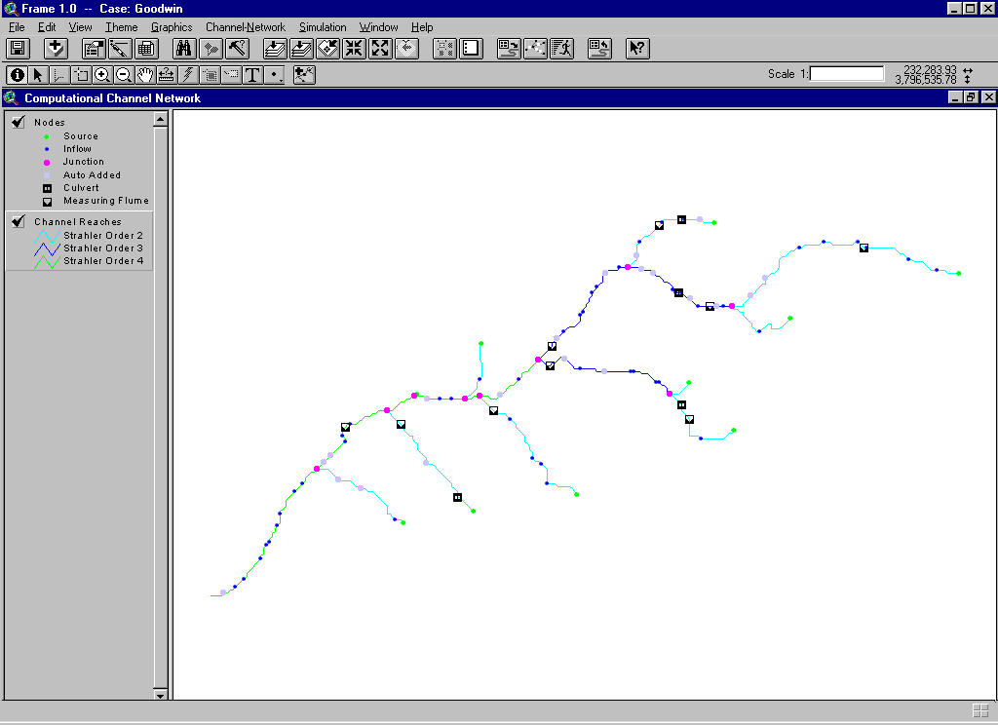

Adding Computational Nodes
The interface for the Computational Channel Network window has a tool that allows the user to interactively add nodes to the computational network. When this tool is active, the user can just click at the point where a node is wanted. FRAME displays an interface where the user confirms the insertion of the node, and asks the user if there is cross section information to be input. The user can choose to input the data at the moment the node is added to the network, postpone the data entry, or let FRAME use its interpolation routines to supply the needed information.
The user can click on or near any channel. If the displayed channels are too small, FRAME may not be able to accurately set the location of the node. The user can use the “Zoom-In” tool to avoid this problem, and then click again. By zooming into a small stretch of channel, the user can set the location of a node with greater accuracy.
When a new node is added, the database tables that describe the channel network are updated. The Node Table gets another record, and the node numbering is changed to account for the new node. The channel Reach containing the new node is split into two new reaches. The Link Table is modified only if the split Reach is the first or the last in the Link. The Subwatershed Table is modified to account for the addition of a new Incremental Area. The Incremental Area where the node was added is also split, a new record is added and the old Incremental Area has some properties altered. FRAME automatically inserts a record in the Cross Section Table to store data related to the newly added node. If the user has provided cross section data, FRAME stores the information in the table. Otherwise, the record is filled with the “No Data” value, and FRAME will later use the interpolation routines to complete the information.
For a detailed description of all these operations, refer to “FRAME – Program Design and Implementation.”

Flow and Sediment Routing

Introduction
The simulation of flow and sediment transport in a network of channels requires the assembly of a large database. The database includes data from various sources, including the output of other modeling components, which is stored using different techniques, such as tables, raster images, and vector graphics. The exchange of information between modeling programs implies resource-consuming data format conversions. Another hurdle is the fact that the output of one modeling component does not usually provide all the input requirements of another. Extra effort must be spent in complementing the necessary information so that two or more programs can be used simultaneously or sequentially.
FRAME simplifies the modeling task since it controls the flow of information among the models, guiding the user through the process of data preparation and substantially reducing the amount of data handled by the user.
FRAME eliminates the tedious task of gathering data describing the channel network. Channel and subwatershed characteristics can be readily extracted from a Digital Elevation Model. FRAME can create the computational mesh automatically. It defines all nodal points and more importantly, the logical relationships between the basic watershed elements: nodes, channel reaches, and subwatersheds. FRAME also helps the input of additional data such as cross sections, channel roughness, and hydraulic structure characteristics, not only by providing a convenient interface with graphical feedback, but also by integrating the new data to the existing database. FRAME takes care of logically connecting the new data to the various watershed elements.
FRAME organizes all data so that they are readily available for the simulation models. Data format conversions and consistency checks are part of the process. The FRAME relational database is gradually built so that all information is consistent, correct, and complete.
For the simulation of flow routing in a channel network using DWAVNET and BEAMS, it suffices to provide the boundary conditions and a couple of parameters. FRAME provides the graphical user interface to guide the user through this process. FRAME controls the simulation models, performing all data input automatically.

Input Parameters And Data Files

Types of Simulation Runs
When the user is satisfied with the network created in the Computational Channel Network window, the flow routing simulations can begin. The only extra requirements for the numerical simulations are a file containing the boundary conditions and a set of options and parameters that are entered through the interface. The Computational Channel Network has a menu labeled Simulation, which has two entries: Parameters and Run.
The Parameters menu entry and corresponding button displays a series of dialog boxes where the user inputs all the information.
FRAME provides three types of run for the flow routing model:
- Initial Conditions and Simulation
- Initial Conditions Only
- Simulation Only
The option Initial Conditions and Simulation instructs the simulation model to automatically determine the initial conditions for the simulation. This is done by gathering all the channel and subwatershed information to estimate a baseflow for all channels. This baseflow is used in the steady state determination of water surface profiles throughout the channel network. The standard-step method is used as a first guess, and then the flow routing model DWAVNET is used to simulate the same steady conditions for a period of time. This adjusts the standard-step method solution and gives a better approximation of the conditions for baseflow. The solution is saved into a data file and can be used later. If more than one simulation is performed for the same channel network, the saved initial conditions file can be used. Having the initial conditions computed, FRAME starts the simulation according to the parameters given by the user.
The option Initial Conditions Only simply asks the user the file format of preference. Three formats are supported: a database file (.dbf), an ASCII text file, or Fortran Unformatted file. The simulation model is started to determine the baseflow and compute the initial water surface profile.
The Simulation Only option is employed if the user already has the initial conditions stored in a data file. FRAME starts the simulation using the contents of this file as initial conditions.

Control Parameters
After the type of simulation run is chosen, FRAME asks for the only two parameters necessary to run the model. A single data input box is shown, where the user is required to provide two numbers:
- Number of Storm Events
- Number of Time Steps in a Day
The first entry is the number of storm events in the boundary conditions file. This file is usually the output of a watershed processes model. The user must provide and know about the contents of this file. The second entry determines how many time steps in a day should be used in the numerical simulations. The documentation of the simulation models discusses the importance of this parameter and suggests a range of values. FRAME provides a default value for this entry.

Boundary Conditions File
The user must specify the boundary conditions for the flow and sediment routing models. The boundary conditions are stored in a data file. They consist of a series of water and sediment discharge hydrographs for each subwatershed, for one or more storm events. FRAME is designed to use the Soil and Water Assessment Tool (SWAT) model for the watershed processes computations. The boundary conditions file is usually created by SWAT. The number of storm events contained in this file must be input through the FRAME interface. The user must also specify the location of this data file in the system. Prior to selecting the file itself, however, the user should inform the type of the file FRAME is going to use. There are three types currently supported: database file (.dbf), ASCII text file, and Fortran Unformatted file. The description of formats for the boundary condition file is given in Appendix C.

Visualization
FRAME provides a very powerful system for the specification of the type and frequency of output of results from the channel models DWAVNET and BEAMS. The system allows the user to choose which variables will be output, for which nodes, and at which frequency.
The channel models treat time with two different scales: a Time Step scale, whose size is a function of the channel geometry and time-dependent flow properties, and a 24-hour Day scale. Flow and transport computations are performed using the Time Step scale. A new state of flow and sediment properties is computed for each time step. Coupling with the watershed model SWAT is made at a Day scale. Values of daily water and sediment discharges are transformed into hydrographs by DWAVNET. Updating of cross section geometry and bank stability analysis are performed only at the end of the simulation day.
The system is designed so that the user can simply specify what charts are to be made when the simulation is over. FRAME provides three basic types of charts:
- Time Series;
- Longitudinal Profiles;
- Cross Sectional Profiles.
A map-based graphical interface is planned. However, the current version provides a table-editing facility for the specification of the charts.
The Visualization menu contains the options for the definition and inspection of the simulation output.
You start by creating a Chart Definition Table that will store all the definitions for the charts you want FRAME to create.
Variables that are going to be stored in these tables are defined through the graphical interface through the Parameters entry of the Simulation menu. The user can create several Chart Definition Tables, and then specify the desired table for the next model simulation.
For Windows 95, 98 and NT systems, FRAME can export data to Microsoft Excel spreadsheet program, which is a convenient means of creating high quality X-Y plots.

Chart Definition Database Table
In order to specify what is the output from the channel flow models DWAVNET and BEAMS, a Chart Definition Table is created. This table stores the definition of several charts that should be available for analysis, after the simulation is completed. DWAVNET and BEAMS will create output tables that will contain the values of user-specified variables for the nodes and output intervals defined in the Chart Definition Table. In future versions this table will be automatically created based on user input on an interactive channel network map. The current version requires the user to fill in the table with the desired values. See the User’s Model for specific instructions.
The Chart Definition Table has the following fields:
Chart Definition Table MD ( MD_ID, MD_CHTNO, MD_CHTTYP,
MD_CHTUNIT, MD_FRMNO, MD_FREQ)
Where the fields are
MD_ID – Record Identifier Number (ID)
MD_CHTNO – Chart Number
MD_CHTTYP –Chart Type
Contains a string identifying the type of chart. The valid values for this field are:
- TIMESERIES – Time Series plot for a single node
- PROFILE – Longitudinal Profile plot for a series of consecutive nodes
- CROSSSECTION – Cross Section Geometry plot
- SEDCLASS – Sediment size-class related output.
MD_CHTUNIT – Unit of the frequency of output
Contains a string identifying the unit for the frequency of output. The valid values for this field are:
- TIMESTEP – Frequency of output is specified in number of Time Steps
- DAY – Frequency of output is specified in Days
MD_FRMNO – FRAME node number
MD_FREQ – Frequency of output, in units defined by the MD_CHTUNIT field.

APPENDIX A
References
Arnold, J.G., Allen, P.M., Bernhardt, G.,1993, A comprehensive surface-groundwater flow model, Journal of Hydrology, 142, 47–69.
Environmental Systems Research Institute, Inc., ESRI, 1996a, Using ArcView GIS, ESRI, Redlands, California.
Environmental Systems Research Institute, Inc., ESRI, 1996b, Avenue. Customization and Application Develop-ment for ArcView, ESRI, Redlands, California.
Garbrecht, J. and Martz, L.W., 1995, An automated digital landscape analysis tool for topographic evaluation, drainage identification, watershed segmentation and subcatchment parameterization, Report No. NAWQL 95-1, National Agricultural Water Quality Laboratory, USDA, Agricultural Research Service, Durant, Oklahoma.
Langendoen, E.J., 1996, Discretization diffusion wave model, Tech. Rep. No. CCHE-TR-96-1, Center for Computational Hydroscience and Engineering, The University of Mississippi, University, Mississippi.
Langendoen, E.J., 1997, DWAVNET: Modifications to Friction Slope Formulation and Solution Method, Tech. Rep. No. CCHE-TR-97-1, C Center for Computational Hydroscience and Engineering, The University of Mississippi, University, Mississippi.
Vieira, D.A., Langendoen, E.J., Bingner, R.L., 1997, FRAME – A Modeling Environment for Watershed Processes, In Proc. Conference on Management of Landscapes Disturbed by Channel Incision, Oxford, MS, 709-715.
Vieira, D.A., Toro, F., Langendoen, E.J., 1997, FRAME – User’s Manual, Tech. Rep. No. CCHE-TR-97-6, Center for Computational Hydroscience and Engineering, The University of Mississippi, University, Mississippi.
Vieira, D.A., Langendoen, E.J., Bingner, R.L., 1998, The FRAME Project: Integrating Watershed and Channel Processes Modeling Using GIS Technology, In Proc. Eighteenth Annual ESRI’s User Conference, San Diego, CA, on CD-ROM.
Zhang, Y., Langendoen, E.J., 1998, An Introduction to BEAMS, Tech. Rep. No. CCHE-TR-98-2, Center for Computational Hydroscience and Engineering, The University of Mississippi, University, Mississippi.

APPENDIX B
Hydraulic Structure Input Data
This appendix describes the data required for the modeling of hydraulic structures. FRAME can model four types of structures: Bridge Crossings, Culverts, Drop Structures, and Measuring Flumes.
This section explains how the physical characteristics of the structures are described in the model. It discusses the meaning of each property, and the selection of values for parameters and coefficients.

Contents
- Bridge Crossings
- Culverts
- Drop Structures
- Measuring Flumes

Bridge Crossings
The following are the required entries to define the geometry of these types of structures:
- Upstream Bridge Invert: This entry specifies the elevation of the channel invert at the upstream side of the bridge.
- Bridge pier loss coefficient: This entry specifies the drag coefficient to be used in calculating pier losses in the momentum equations.
The following pier loss drag coefficients can be used:
Square piers 2.00
Semi-circular piers 1.33
- Bridge pier shape coefficient: This entry specifies the pier shape coefficient, K, for use in Yarnell’s energy equation for Class A flow.
Typical pier shape coefficients are given in the following table:
Pier Description | Illustration | Pier Shape Coefficient
Semicircular nose and tail |  | 0.90
Twin-cylinder piers with diaphragm |  | 0.95
Twin-cylinder piers without diaphragm |  | 1.05
90° triangular nose and tail |  | 1.05
Square nose and tail |  | 1.25
- Bridge opening side slopes: This entry is used to specify the side slopes of the trapezoidal channel under the bridge. It represents the number of horizontal units for each vertical unit in the channel side slope.
- Bridge opening bottom width: This entry specifies the total bottom width of bridge opening. Any bottom width obstructed by bridge piers should be included in this value. The pier width obstruction will be subtracted out during the analysis.
- Bridge pier width: This entry specifies the total width of obstructions (piers).

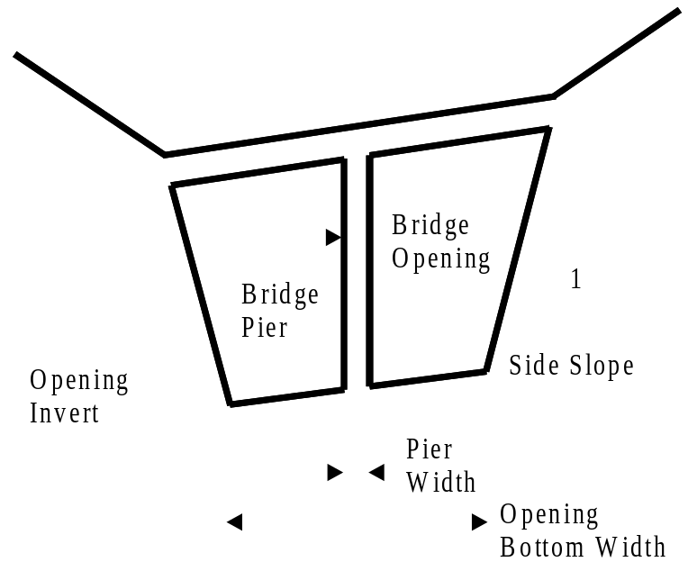

Culverts
FRAME supports both pipe and box culverts.
The following are the required entries to define the geometry of these types of structures:
- Number of culverts in a cross section: This data entry allows you to specify the number of identical culverts that exist at the cross-section. All culverts must be identical; they must have the same cross-sectional shape, upstream invert elevation, downstream invert elevation, roughness coefficient, and inlet shape.
- Length: The culvert length is measured along the centerline of the culvert. The culvert length is used to determine the slope of the culvert.

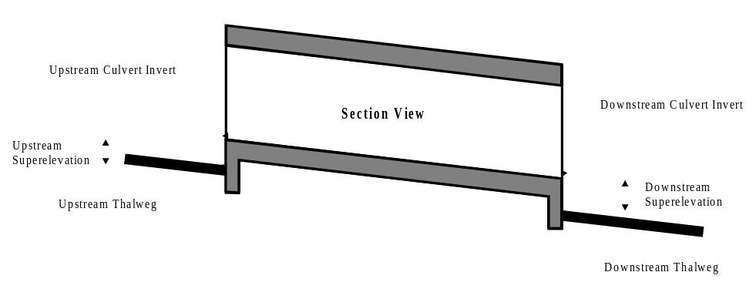
Culvert section view

- Rise or diameter: This entry specifies the inside diameter of a pipe culvert, or the inside height of a box culvert.

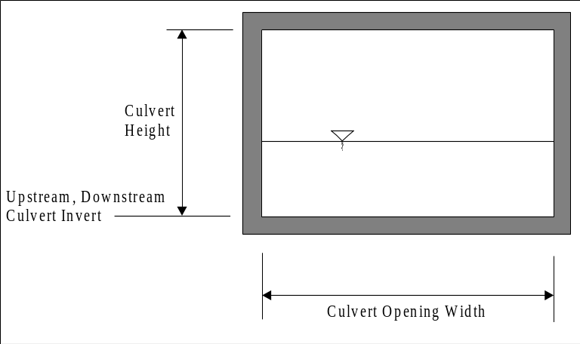
Box culvert cross-section

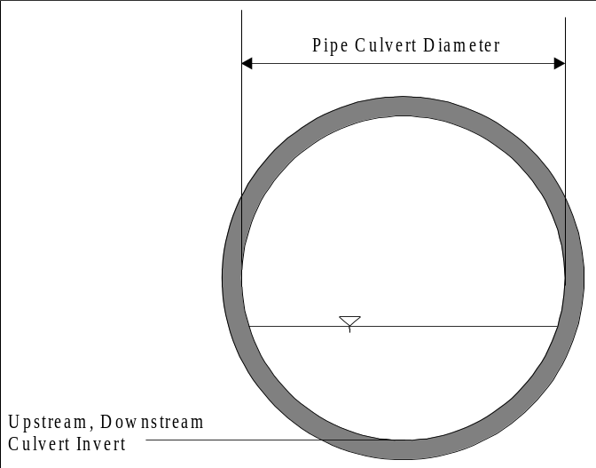
Pipe culvert cross-section

- Span: Specifies the inside width of the box culvert. For a pipe culvert, this value corresponds to the inside diameter. Most box culverts have chamfered corners on the inside. These chamfers are ignored by the special culvert method in computing the cross sectional area of the culvert opening. Some manufacturers’ literature contains the true cross-sectional area of each size box culvert, considering the reduction in area caused by the chamfered corners. If you wish to consider the loss in area due to chamfers, then you should reduce the box culvert opening width. You should not reduce the box culvert height, because the program uses the culvert height to determine the submergence of the culvert inlet and outlet.
- Downstream invert: Specifies the culvert invert elevation at the downstream opening. Culverts with adverse (negative) slopes are not allowed. Therefore, the downstream invert elevation must be equal to, or less than, the upstream invert elevation.
- Upstream invert: Specifies the culvert invert elevation at the upstream opening. The upstream invert elevation must be equal to, or greater than, the downstream invert elevation.
- Downstream superelevation: This entry is the difference between the downstream culvert invert and the immediate thalweg elevation (see figure).
- Upstream superelevation: This entry is the difference between the upstream culvert invert and the immediate thalweg elevation (see figure).
- Surface roughness (Manning’s): Specifies the Manning’s roughness coefficient to be used in friction loss calculations.
- Entrance loss coefficient: Specifies the culvert entrance loss coeffcient to be used to compute the head loss at the culvert entrance.
The following table lists some suggested values for culvert entrance loss coefficients.

Type of Culvert and Design Entrance | k_{e}
Reinforced Concrete Pipe Culvert
Projecting from fill, socket pipe end | 0.20
Projecting from fill, square cut pipe end | 0.20
End-section conforming to fill slope | 0.50
Mitered to conform to fill slope | 0.70
Concrete Pipe with Headwall or Headwall and Wingwalls
Socket end of pipe | 0.10
Rounded entrance | 0.10
Square cut end of pipe | 0.50
Corrugated Metal Pipe
Headwall, square edge | 0.50
Headwall and wingwalls, square edge | 0.50
End-section conforming to fill slope | 0.50
Mitered to conform to fill slope | 0.70
Projecting from fill (no headwall) | 0.80
Box Culvert (headwall parallel to embankment-no wingwalls)
Rounded edges | 0.20
Square edge on three edges | 0.50
Box Culvert (wingwalls at 30º to 75º to barrel)
Rounded crown edge | 0.20
Square edge crown | 0.40
Box Culvert (wingwalls at 10º to 25º to barrel)
Square edge crown | 0.50
Box Culvert (wingwalls parallel to culvert)
Square edge crown | 0.70
Entrance loss coefficients, k_{e}, for pipe and box culverts (Bureau of Public Roads, 1958)

- Chart number and Scale number: These entries specify the chart number and scale number. The FHWA chart number and scale number refer to a series of nomographs published in 1965 by the Bureau of Public Roads (now called the Federal Highway Administration). These nomographs allowed the inlet control headwater to be computed for different types of culverts operating under a wide range of flow conditions. These nomographs, and others constructed using the original methods, were published in 1985 (FHWA, 1985). The following tables list the FHWA chart and scale numbers for pipe culverts and box culverts.
For Pipe Culverts:
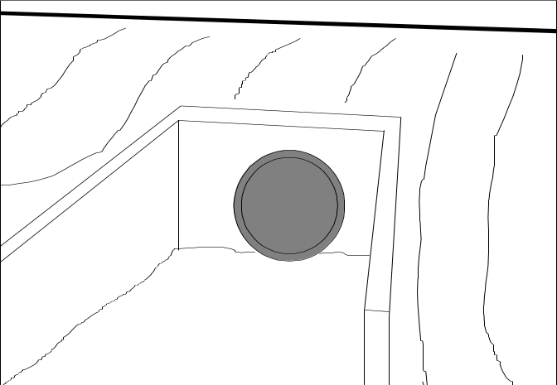
Culvert inlet with headwall and wingwalls (FHWA Chart 1 and Chart 2)

Description | Chart Number | Scale Number
Concrete Pipe Culvert
Square edge entrance with headwall (see figure) | 1 | 1
Groove end entrance with headwall (see figure) | 1 | 2
Groove end entrance, pipe projecting from fill (see figure) | 1 | 3
Corrugated Metal Pipe Culvert
Headwall (see figure) | 2 | 1
Mitered to conform to slope (see figure) | 2 | 2
Pipe projecting from fill (see figure) | 2 | 3
Concrete Pipe Culvert, Beveled Ring Entrance
Small bevel (see figure) | 3 | 1
b/D = 0.042
a/D = 0.063
c/D = 0.042
d/D = 0.083
Large bevel (see figure) | 3 | 2
b/D = 0.083
a/D = 0.125
c/D = 0.042
d/D = 0.125
FHWA chart and scale numbers for pipe culverts (FHWA, 1985)

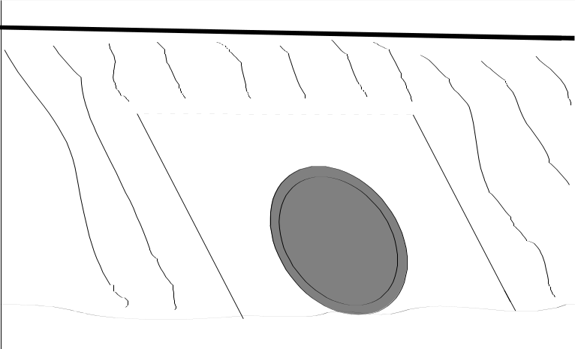
Culvert inlet mitered to conform to slope (FHWA Chart 2)

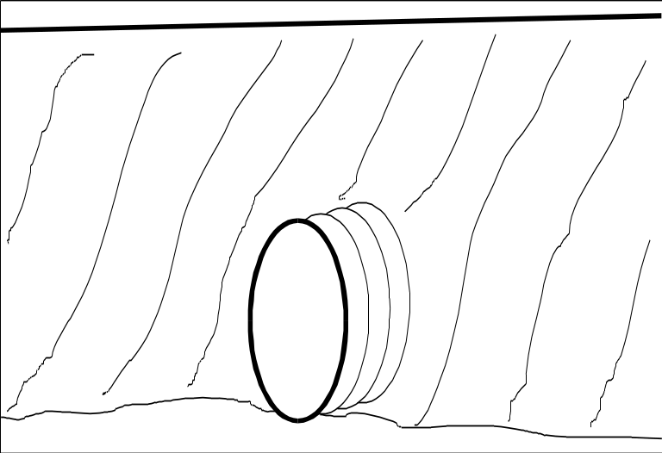
Culvert inlet projecting from fill (FHWA Chart 1 and Chart 2)

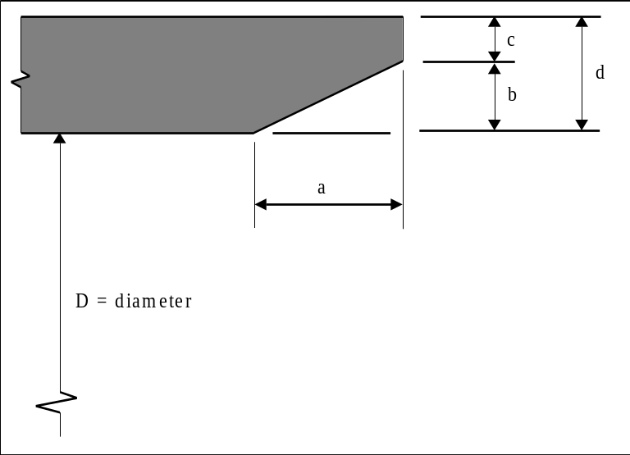
Culvert inlet with beveled ring entrance (FHWA Chart 3)

For Box Culverts:

Description | Chart Number | Scale Number
Box Culvert with Flared Wingwalls (see figure)
Wingwalls flared 30º to 75º | 8 | 1
Wingwalls flared 90º to 15º | 8 | 2
Wingwalls not flared (sides extended straight) | 8 | 3
Box Culvert with Flared Wingwalls and Inlet Top Edge Bevel (see figures)
Wingwall flared 45º, inlet top edge bevel =  0.43D | 9 | 1
Wingwall flared 18º to 33.7º, inlet top edge  bevel = 0.083D | 9 | 2
Box Culvert, 90º Headwall, Chamfered or Beveled Inlet Edges (see figure)
Inlet edges chamfered ¾ inch | 10 | 1
Inlet edges beveled ½ in/ft at 45º (1:1) | 10 | 2
Inlet edges beveled 1 in/ft at 33.7º (1:1.5) | 10 | 3
Box Culvert, Skewed Headwall, Chamfered or Beveled Inlet Edges (see figure)
Headwall skewed 45º, inlet edges chamfered ¾  inch | 11 | 1
Headwall skewed 30º, inlet edges chamfered ¾  inch | 11 | 2
Headwall skewed 15º, inlet edges chamfered ¾  inch | 11 | 3
Headwall skewed 15º to 45º, inlet edges beveled | 11 | 4
Box Culvert, Non-Offset Flared Wingwalls, ¾ Inch Chamfer at Top of Inlet (see figure)
Wingwalls flared 45º (1:1), inlet not skewed | 12 | 1
Wingwalls flared 18.4º (3:1), inlet not skewed | 12 | 2
Wingwalls 18.4º (3:1), inlet skewed 30º | 12 | 3
Box Culvert, Offset Flared Wingwalls, Beveled Edge at Top of Inlet (see figure)
Wingwalls flared 45º (1:1), inlet top edge bevel  = 0.042D | 13 | 1
Wingwalls flared 33.7º (1:5:1), inlet top edge  bevel = 0.083D | 13 | 3
Wingwalls flared 18.4º (3:1), inlet top edge  bevel = 0.083D | 13 | 4
FHWA chart and scale numbers for box culverts (FHWA, 1985)

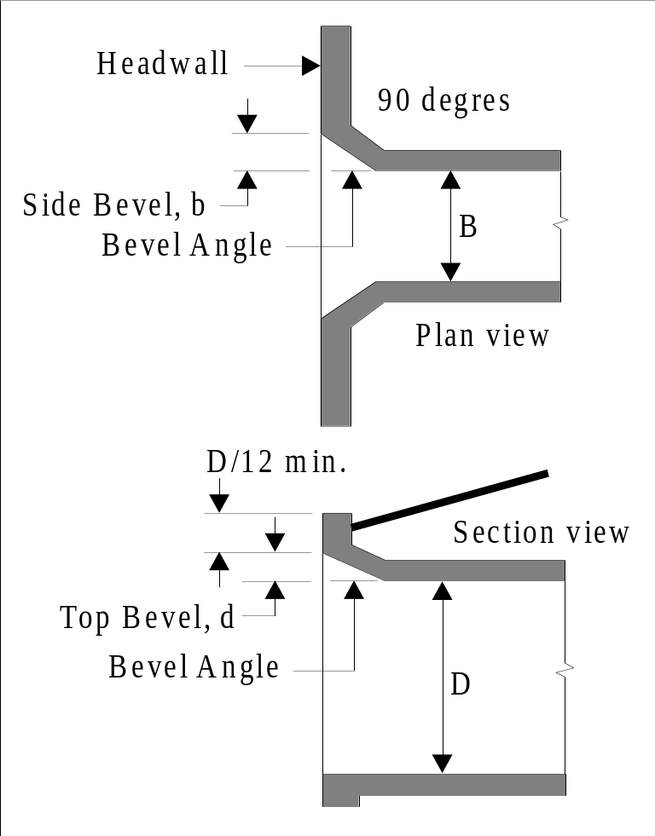
Inlet side and top edge bevel with 90º headwall (FHWA Chart 10)

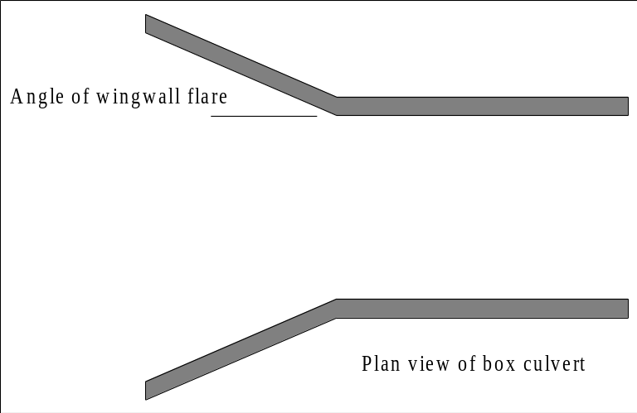
Flared wingwalls (FHWA Chart 8 and Chart 9)

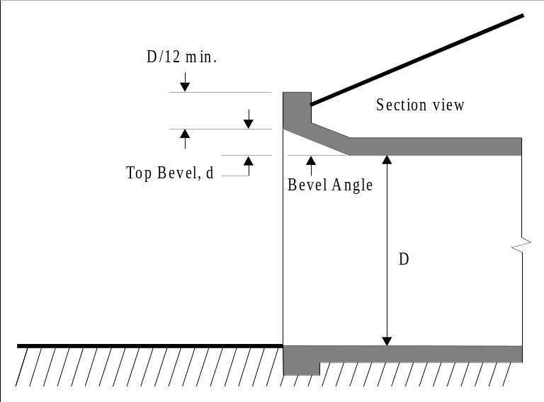
Inlet top edge bevel (FHWA Chart 9)

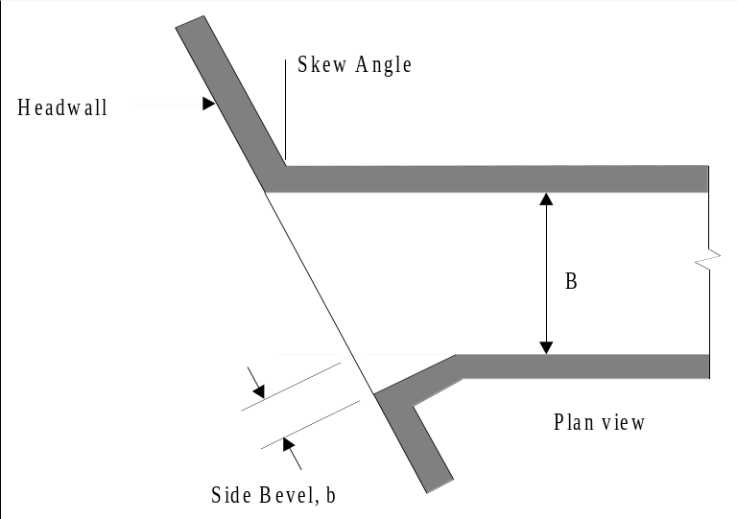
Inlet side and top edge bevel with skewed headwall (FHWA Chart 11)

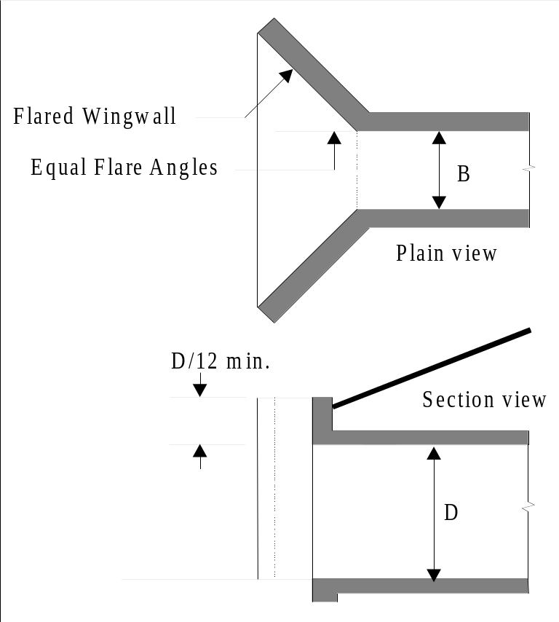
Non-offset flared wingwalls (FHWA Chart 12)

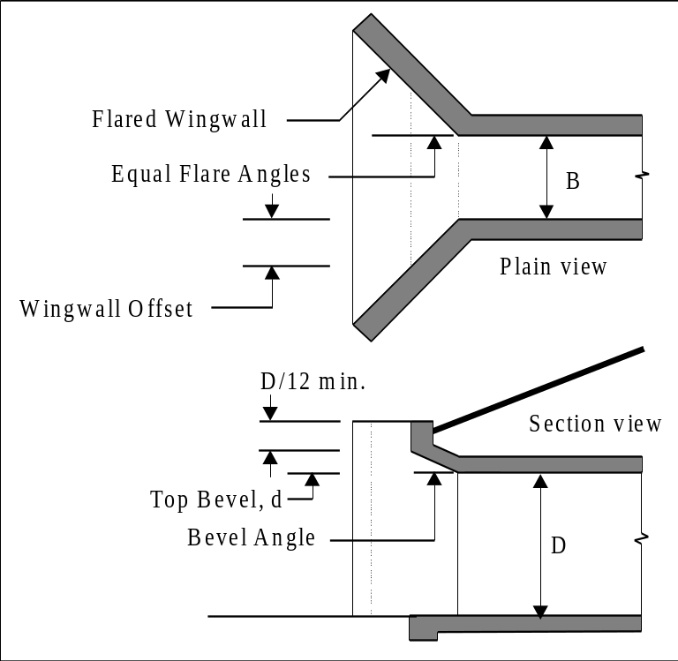
Offset flared wingwalls (FHWA Chart 13)

Drop Structures
The following are the required entries to define the geometry of drop structures:
- Bottom Width: Specifies the bottom width of the drop structure.
- Loss Coefficient: A coefficient used to compute head losses at the drop structure.
- Length: The drop structure length is measured along the centerline of the structure.
- Side Slopes: This entry is used to specify the side slopes of the trapezoidal channel in the structure. It represents the number of horizontal units for each vertical unit in the structure side slope.
- Upstream Invert: This entry specifies the elevation of the channel invert at the entrance of the structure.
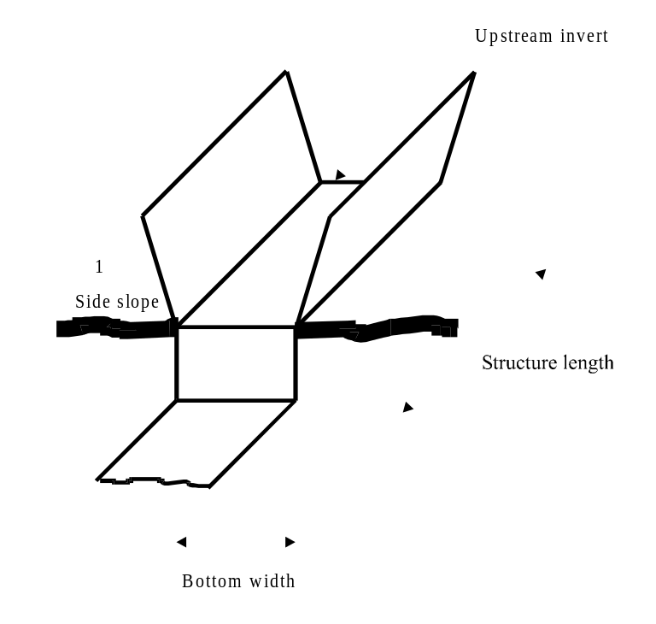

Measuring Flumes
The following are the required entries to define the geometry of these types of structures:
- Surface Roughness: Specifies the Manning’s roughness coefficient to be used in friction loss calculations.
- Length: The measuring flume length is measured along the centerline of the structure.
- Compound Cross Section: This entry specifies if the measuring flume cross section is composed or not. Use 1 (one) for compound cross sections and 0 (zero) for triangular cross sections.

- Upstream Invert Elevation: Specifies the invert elevation at the upstream end of the measuring flume.
- Measuring Section Elevation: Specifies the elevation of the flume invert at the measuring section.
- Downstream Superelevation: This entry is the difference between the downstream flume invert and the immediate thalweg elevation.
- Upstream Superelevation: This entry is the difference between the upstream measuring flume invert and the immediate thalweg elevation.
- Number of Segments in Rating Curve: Number of segments in the Discharge vs Flow Depth curve. This entry must be a number between 1 and 4. For each measuring flume, a Discharge vs Flow Depth Curve must be given. The curve is an exponential function of the form 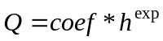 and may be split into up to four segments.
For each segment in the Rating Curve the three parameters below must be provided:
- Break Point Depth: A depth that defines the ending point of a segment in the rating curve.
- Coefficient: Value of the coefficient in the exponential function.
- Exponent: Value of the exponent in the exponential function.
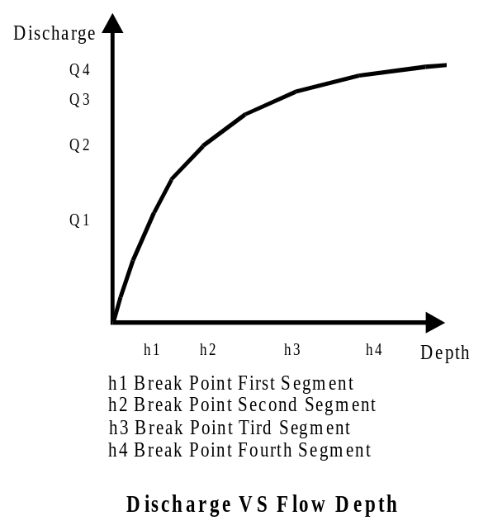

APPENDIX C
Data File Formats
This appendix describes the formats for the input files used by FRAME.

Contents
- Digital Elevation Model Files
- Cross Section Geometry Files
- Bed Sediment Files
- Bank Sediment Files
- Hydraulic Structures File
- Boundary Conditions Files
- Colormap File

Digital Elevation Model Files

ArcInfo ASCII Grid
GIS files can be created using the GIS software ArcInfo or ArcView, which can convert the data from files in other formats such as the USGS DEM file. In ArcInfo, use the GRIDASCII command to export the grid to an ASCII file. In ArcView, use the Export Grids Option in the File Menu.
You can also create this type of file using a text editor, following the specifications below.
The ASCII Grid files are composed of two parts: the header and the cell values. The header has the following parameters that can be written in any order:
- ncols: Total number of columns in the DEM.
- nrows: Total number of rows in the DEM.
- xllcorner: East-West coordinate for the lower left corner of the DEM.
- yllcorner: North-South coordinate for the lowest left corner of the DEM.
- cellsize: Size of the DEM cell.
- nodata_value: The value assigned to cells for which there is no data available.
The cell elevation values are written immediately after the header. The values are given in a row oriented fashion starting from the upper left corner cell. The elevation values are integer numbers separated by spaces or the end-of-line characters.
The following is an example of a DEM in ArcInfo ASCII Grid format:
ncols 4
nrows 5
xxllcorner 231435
yyllcorner 3790995
cellsize 30
nodata_value –9999
100 105 110 96
98 100 104 98
98 102 102 99
102 103 104 102
100 99 101 101

Cross Section Files
Cross Section information can be provided in a single data file. This process may be more convenient when compared with the node-by-node entry provided by the FRAME interface, in case a large number of entries are to be provided.
Each cross section data record is defined in FRAME by the following entries:
- Node Number: Each cross section record is related to the channel network database using the FRAME node number.
- W and Z coordinates: The cross section is defined using eight points according to the following scheme:
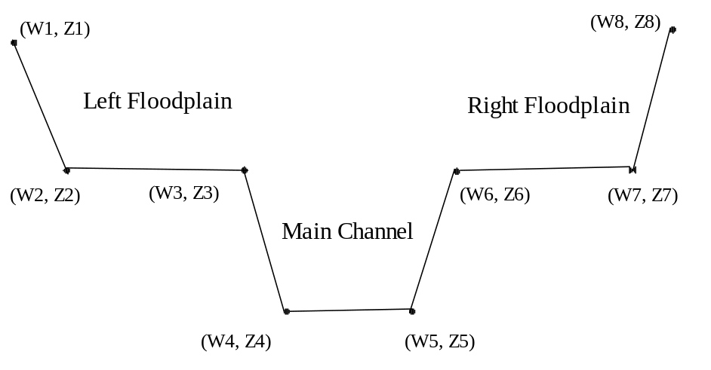
Each cross section record must have values for its eight points. For cross sections without floodplains, points 1 to 3 and 6 to 8 share the same coordinates. Distances and elevations are given in meters.
- Roughness Coefficients: Manning’s roughness coefficient values for each of the following zones: Main Channel, Left Floodplain and Right Floodplain. You must supply three values, even if the floodplains are not present.
FRAME requires that the Source Nodes, the End of Link Nodes and the Junction Nodes of the Channel Network have cross section data defined by the user. Cross section data for the Inflow Nodes either are defined by the user or are automatically defined by FRAME through interpolation.
Cross Section Files can be provided either in ASCII format or in dBase format.

ASCII Format
Each cross section data record is written in the following format:
Node
W1 | Z1 |  |  | W2 |  |  | Z2 |  | W3 |  |  | Z3 |  | W4 |  | Z4
W5 | Z5 |  |  | W6 |  |  | Z6 |  | W7 |  |  | Z7 |  | W8 |  | Z8
RoughMC |  |  | RoughLFP |  |  | RoughRFP
The set of data for each cross section must be written in four lines as above: the first line contains the Node Number. The second line contains the first four pairs of coordinates. The third contains the remaining pairs of coordinates. The fourth line contains the three roughness coefficients. Negative values can be used for cross-section coordinates.
Cross section records do not have to be in any particular order. However, the node numbers must be present in the channel network.
Commas or Spaces separate numbers. The number of spaces between numbers is not relevant.
Comments can be added in between sets of cross section data. Comment lines must start with a non-numerical character.
The following is an extract of the Cross Section File for Goodwin Creek:
1
.0000 92.4800 .0000 92.4800 .0000 92.4800 6.1000 88.6100
17.3700 88.3900 25.9100 92.6300 25.9100 92.6300 25.9100 92.6300
.060 .060 .060
2
.0000 90.9500 .0000 90.9500 .0000 90.9500 6.1000 87.0800
17.3700 86.8700 25.9100 91.1000 25.9100 91.1000 25.9100 91.1000
.060 .060 .060
3
-1.7300 75.9700 -1.7300 75.9700 -1.7300 75.9700 5.7900 71.5000
6.4000 71.5000 12.4300 75.9200 12.4300 75.9200 12.4300 75.9200
.060 .060 .060
4
.0000 89.9500 .0000 89.9500 .0000 89.9500 2.7400 88.7900
5.4900 88.3900 8.8400 90.5600 8.8400 90.5600 8.8400 90.5600
.060 .060 .060
5
-3.0900 79.9900 -3.0900 79.9900 -3.0900 79.9900 3.0500 75.0000
4.8800 75.3400 11.6900 80.0200 11.6900 80.0200 11.6900 80.0200
.060 .060 .060
6
.0000 91.7100 .0000 91.7100 .0000 91.7100 5.4900 90.0700
9.4500 89.9200 10.9700 92.1700 10.9700 92.1700 10.9700 92.1700
.060 .060 .060

Dbase Format
A Cross Section File can be provided in the dBase format. This option is useful if the user has already the cross sections stored in a database file created by ArcView or a database management system. The file is similar to the database file format used by FRAME for internal use, except node numbers replace record ID numbers. The field names are not considered when importing this type of file. The database file must have the following fields, in the same order as shown in the following table.
Field Contents | Type
Node Number | Number
Origin; value = “USERSPEC” | String
Left Valley W Coordinate (1) | Number
Left Valley Elevation (1) | Number
Left Flood Plain Bank Toe W Coordinate (2) | Number
Left Flood Plain Bank Toe Elevation (2) | Number
Left Bank Top W Coordinate (3) | Number
Left Bank Top Elevation (3) | Number
Left Bank Toe W Coordinate (4) | Number
Left Bank Toe Elevation (4) | Number
Right Bank Toe W Coordinate (5) | Number
Right Bank Toe Elevation (5) | Number
Right Bank Top W Coordinate (6) | Number
Right Bank Top Elevation (6) | Number
Right Flood Plain Bank Toe W Coordinate (7) | Number
Right Flood Plain Bank Toe Elevation (7) | Number
Right Valley W Coordinate (8) | Number
Right Valley Elevation (8) | Number
Roughness Coefficient, Main Channel | Number
Roughness Coefficient, Left Flood Plain | Number
Roughness Coefficient, Right Flood Plain | Number
Cross Section Type* | String
* Cross section type strings are:
MC – Main Channel only,
MCLF – Main Channel and Left Flood Plain,
MCLFRF or MCRFLF – Main Channel, Left and Right Flood Plains.

Bed Sediment Files
FRAME provides an alternative method for entry of bed sediment data: you can prepare a file with the bed sediment data for the channel network, instead of using the GUI tools.
Perhaps the most flexible method is to employ ASCII data files. A variable format allows you to specify the data without having to create a large data file with a text editor. For convenience, FRAME also imports dbf files.

ASCII Format
The Bed Sediment ASCII file was designed to offer flexibility. There are two variants of the same file, which are identified by certain keywords. The format for these files is flexible, but they are not free-format files. You can enter comment lines by placing either a # or a ! at the beginning of the line. In addition, at any data line, everything following these special characters is considered a comment. Blank lines are also disregarded.

Spatially Constant Distribution
You can specify a single set of properties, and FRAME will assign this set of properties to all nodes of the channel network. This option has the tag “SPATIALLY CONSTANT” as the first entry in the file. Following is a set of five data lines, as illustrated next:

# Comment Line 1
! Comment Line 2
SPATIALLY CONSTANT

D50_MC D50_LF D50_RF
D90_MC D90_LF D90_RF
CL1_MC CL2_MC CL3_MC CL4_MC CL5_MC CL6_MC CL7_MC CL8_MC CL9_MC
CL1_LF CL2_LF CL3_LF CL4_LF CL5_LF CL6_LF CL7_LF CL8_LF CL9_LF
CL1_RF CL2_RF CL3_RF CL4_RF CL5_RF CL6_RF CL7_RF CL8_RF CL9_RF

where:
MC indicates Main Channel,
LF indicates Left Flood Plain,
RF indicates Right Flood Plain, and
CL1…CL9 are percent fractions for each of the nine pre-defined sediment classes.

Spatially Varied Distribution
If the bed sediment properties vary across the channel network, you can use the “SPATIALLY VARIED” version. In this variant form, data are specified for nodal points. You do not have to specify properties for all nodes in the network. However, you are required to specify properties for nodes of type:
- Source (code 0)
- Junctions (code 2)
- End of Channels (code 3)
The format is similar to the SPATIALLY CONSTANT version, except several sets of bed properties are specified, with node number preceding each set. The following in an excerpt of the data file for Goodwin Creek, distributed with FRAME.

# GOODWIN CREEK WATERSHED
# BED SEDIMENT DATA - FORMAT FRAME 1.0
# SPATIALLY VARIED VERSION
# CREATED BY DALMO VIEIRA, MARCH 26, 1998

SPATIALLY VARIED # Do not modify this line

# Required nodes are: sources, end-of-channels, junctions

1 !BED 10 - source
7.19 7.19 7.19
35.98 35.98 35.98
0.000 0.000 0.041 0.232 0.083 0.064 0.094 0.252 0.234
0.000 0.000 0.041 0.232 0.083 0.064 0.094 0.252 0.234
0.000 0.000 0.041 0.232 0.083 0.064 0.094 0.252 0.234

3 !BED 10 - end
7.19 7.19 7.19
35.98 35.98 35.98
0.000 0.000 0.041 0.232 0.083 0.064 0.094 0.252 0.234
0.000 0.000 0.041 0.232 0.083 0.064 0.094 0.252 0.234
0.000 0.000 0.041 0.232 0.083 0.064 0.094 0.252 0.234

4 !BED 10 - source
7.19 7.19 7.19
35.98 35.98 35.98
0.000 0.000 0.041 0.232 0.083 0.064 0.094 0.252 0.234
0.000 0.000 0.041 0.232 0.083 0.064 0.094 0.252 0.234
0.000 0.000 0.041 0.232 0.083 0.064 0.094 0.252 0.234

5 !BED 10 - end
7.19 7.19 7.19
35.98 35.98 35.98
0.000 0.000 0.041 0.232 0.083 0.064 0.094 0.252 0.234
0.000 0.000 0.041 0.232 0.083 0.064 0.094 0.252 0.234
0.000 0.000 0.041 0.232 0.083 0.064 0.094 0.252 0.234

Dbase Format
If you already have the input data stored in a relational database, maybe exporting the data to a dbf file is a convenient option. You can also use this option if you have the Bed Sediment data files from a previous FRAME simulation.
There are two disadvantages by using this option. First, you have to specify two data files. The dBase version of the Bed Sediment Table uses the same table schema of the FRAME database. Grain size distributions are saved into a separate table. You must also provide this second file.
The second disadvantage is that FRAME is unable to perform checks on the supplied data. FRAME cannot detect errors in the relationships between records of the two tables aforementioned.
The format for the Bed Sediment Table (SB) is described in the table below:
Field Name | Type | Contents
SB_ID | Number | Record ID number
SB_D50MC | Number | d₅₀ for the Main Channel
SB_D50LF | Number | d₅₀ for the Left Flood Plain
SB_D50RF | Number | d₅₀ for the Right Flood Plain
SB_D90MC | Number | d₉₀ for the Main Channel
SB_D90LF | Number | d₉₀ for the Left Flood Plain
SB_D90RF | Number | d₉₀ for the Right Flood Plain
SB_SGIDMC | Number | Record ID in the SG Table, Main Channel
SB_SGIDRF | Number | Record ID in the SG Table, Left Flood Plain
SB_SGIDRF | Number | Record ID in the SG Table, Right Flood Plain
SB_CSTYPE | String | Cross Section type*
SB_ORIGIN | String | Origin; value = USERSPEC
* Cross section type strings are: MC, MCLF, MCLFRF, or MCRFLF.

Bank Sediment Files
FRAME provides two types of data files for the supply of Bank Sediment properties. Similarly to the bed sediment tables, the ASCII format is designed to be flexible and concise. You can also use dBase files to provide the required data.

ASCII Format
Bank sediment data are easily specified using one of the four variants of ASCII files FRAME supports. Similarly to the Bed Sediment data, you can specify a single set that will be applied to all nodes, or you can provide data on a node-to-node basis. There is the additional option of determining if the properties of the left and right channel banks differ or not. The format for these files is flexible, but they are not free-format files. You can enter comment lines by placing either a # or a ! at the beginning of the line. In addition, at any data line, everything following these special characters is considered a comment. Blank lines are also disregarded.

Spatially Constant Distribution
If you want to specify the same set of parameters for all nodes, specify “SPATIALLY CONSTANT” as the first non-comment line in the data file. The second data line must have either of the following characters: “BANKS EQUAL” or “BANKS DIFFER”. If you choose BANKS EQUAL, the set will have parameters that are valid for both banks. If you use “BANKS DIFFER” the set will have separate entries for the left and right channel banks.
The following is a data set for a “SPATIALLY CONSTANT”, “BANKS EQUAL” data file:

# Comment Line 1
! Comment Line 2

SPATIALLY CONSTANT
BANKS EQUAL

! 5 properties for both banks:
D50 BulkDensity ShearStressCoeff Cohesion FrictionAngle

! 9 size class percent fractions:
CL1 CL2 CL3 CL4 CL5 CL6 CL7 CL8 CL9

where:
BulkDensity indicates the Sediment Bulk Density,
ShearStressCoeff indicates the Shear Stress Coefficient,
Cohesion indicates the Cohesion Coefficient,
FrictionAngle indicates the Friction Angle Coefficient, and
CL1…CL9 are percent fractions for each of the nine pre-defined sediment classes.

If the option “BANKS DIFFER” is used, the file becomes:

# Comment Line 1
! Comment Line 2

SPATIALLY CONSTANT
BANKS DIFFER

! 5 properties for the left bank:
D50 BulkDensity ShearStressCoeff Cohesion FrictionAngle
! 5 properties for the right bank:
D50 BulkDensity ShearStressCoeff Cohesion FrictionAngle

! 9 size class percent fractions for the left bank:
CL1 CL2 CL3 CL4 CL5 CL6 CL7 CL8 CL9
! 9 size class percent fractions for the right bank:
CL1 CL2 CL3 CL4 CL5 CL6 CL7 CL8 CL9

Spatially Varied Distribution
If the bank sediment properties vary across the channel network, you can use the “SPATIALLY VARIED” keyword and provide data for several nodes in the network. You are not required to provide data for all nodes, but you must enter data for all nodes of type:
- Source (code 0)
- Junctions (code 2)
- End of Channels (code 3)
The format is similar to the SPATIALLY CONSTANT version, except several sets of bank properties are specified, with node number preceding each set. The following in an excerpt of the data file for Goodwin Creek, distributed with FRAME, which uses the keyword “BANKS EQUAL”.

# GOODWIN CREEK WATERSHED
# BANK SEDIMENT DATA - FORMAT FRAME 1.0
# CREATED BY DALMO VIEIRA, MARCH 26, 1998

# Properties Vary from node to node;
# Properties for Right and Left Banks are the same:

Spatially Varied !Do not modify this line
Banks Equal !Do not modify this line

# Nodes that require property specification are:
# Sources, ends and channel junctions

!BANK 1

1
0.0003 2000.0 1.10 32000.0 0.35
0.391 0.211 0.177 0.160 0.018 0.027 0.015 0.001 0.000

3
0.0003 2000.0 1.10 32000.0 0.35
0.391 0.211 0.177 0.160 0.018 0.027 0.015 0.001 0.000

4
0.0003 2000.0 1.10 32000.0 0.35
0.391 0.211 0.177 0.160 0.018 0.027 0.015 0.001 0.000

5
0.0003 2000.0 1.10 32000.0 0.35
0.391 0.211 0.177 0.160 0.018 0.027 0.015 0.001 0.000

6
0.0003 2000.0 1.10 32000.0 0.35
0.391 0.211 0.177 0.160 0.018 0.027 0.015 0.001 0.000

11
0.0003 2000.0 1.10 32000.0 0.35
0.391 0.211 0.177 0.160 0.018 0.027 0.015 0.001 0.000

Dbase Format
Similarly to the Bed Sediment tables, you must provide a table containing bank sediment properties, and a separate table containing the Grain Size Distribution referred in the primary table.
It is important to make sure both tables are compatible with each other. FRAME cannot detect errors in record relationships between the two tables.
The format for the Bank Sediment Table (SK) is described in the table below:
Field Name | Type | Contents
SK_ID | Number | Record ID number
SK_D50LB | Number | d₅₀ for the Left Bank
SK_BLKDNLB | Number | Sediment Bulk Density, Left Bank
SK_SSCLB | Number | Shear Stress Coefficient, Left Bank
SK_COHESLB | Number | Cohesion Coefficient, Left Bank
SK_FRANGLB | Number | Friction Angle Coefficient, Left Bank
SK_D50RB | Number | d₅₀, Right Bank
SK_BLKDNRB | Number | Sediment Bulk Density, Right Bank
SK_SSCRB | Number | Shear Stress Coefficient, Right Bank
SK_COHESRB | Number | Cohesion Coefficient, Right Bank
SK_FRANGRB | Number | Friction Angle Coefficient, Right Bank
SK_SGIDLB | Number | Record ID in the SG Table, Left Bank
SK_SGIDRB | Number | Record ID in the SG Table, Right Bank
SK_ORIGIN | String | Origin; value = USERSPEC

Grain Size Distribution Table
The Grain Size Distribution Table (SG) stores percent fractions for each of the nine pre-defined sediment classes used by BEAMS. This table is created by FRAME when you provide bed and bank sediment data, either through the GUI or by importing ASCII files. If you decide to provide bed and/or bank data using dBase tables, you must also provide the Grain Distribution Table. Note that this table is shared by both the Bed Sediment and the Bank Sediment tables. Record ID’s of the SG table are referenced by the SB and SK tables. You must provide tables that are compatible with each other.
The format for the Grain Size Distribution Table is given in the table below:
Field Name | Type | Contents
SG_ID | Number | Record ID number
SG_CL1 | Number | Percent fraction for sediment class no. 1
SG_CL2 | Number | Percent fraction for sediment class no. 2
SG_CL3 | Number | Percent fraction for sediment class no. 3
SG_CL4 | Number | Percent fraction for sediment class no. 4
SG_CL5 | Number | Percent fraction for sediment class no. 5
SG_CL6 | Number | Percent fraction for sediment class no. 6
SG_CL7 | Number | Percent fraction for sediment class no. 7
SG_CL8 | Number | Percent fraction for sediment class no. 8
SG_CL9 | Number | Percent fraction for sediment class no. 9

Sediment Classes Definition Table
The Sediment Classes Table (SD) is provided with the distribution of FRAME. It contains the definition of the nine sediment classes used by BEAMS and its submodel SEDTRA. The contents of this table should not be modified, and are given here as reference in the following table:
ID Field | Representative Diam | Upper Diam | Specific Gravity
SD_ID | SD_DIAM | SD_UPDIAM | SD_SPCGRV
1 | 0.0160 | 0.0250 | 2.6500
2 | 0.0400 | 0.0650 | 2.6500
3 | 0.1270 | 0.2500 | 2.6500
4 | 0.4580 | 0.8410 | 2.6500
5 | 1.2970 | 2.0000 | 2.6500
6 | 2.8280 | 4.0000 | 2.6500
7 | 5.6570 | 8.0000 | 2.6500
8 | 13.4540 | 22.6270 | 2.6500
9 | 33.3630 | 50.0000 | 2.6500

Hydraulic Structures File
The Hydraulic Structure File is used to supply data for several structures, in a manner similar to the cross section geometry and sediment data files. Otherwise, it may be easier to use the Add Structure tool of the graphical user interface.
In this file, the user can specify data for the four different types of structures supported by FRAME: bridge crossings, culverts, drop structures and measuring flumes.
The Hydraulic Structures File is in ASCII format. The order of the structures in the input file is not important.
See the Appendix B for a complete description of the required data for each structure, the meaning of each property and values for parameters and coefficients. The following is an example of a Hydraulic Structure File:
2 !----> Total Number of hydraulic structures

! HYDRAULIC STRUCTURES DATA FILE
! REVISED: September, 1997
! THIS FILE: November 20, 1997

! THIS IS NOT A FREE-FORMAT FILE.
! FIRST LINE OF THIS FILE MUST CONTAIN THE TOTAL NUMBER OF HYDRAULIC
! STRUCTURES
! COMMENTS START WITH AN EXCLAMATION MARK, BLANK LINES ARE ALLOWED
! NO COMMENT OR BLANK LINES ALLOWED WITHIN DATA ENTRIES OF THE SAME STRUCTURE
! STRUCTURE DATA ENTRIES MUST BE IN THE CORRECT ORDER

! TEMPLATE FOR BRIDGE CROSSINGS
! =============================

! BRIDGE No. X - COMMENTS
! bridgecrossing !Structure Type
! xxxxxx.xx !X-Coordinate
! xxxxxxx.xx !Y-Coordinate
! xx.xx !Upstream bridge invert
! x.xx !Bridge pier loss coefficient
! x.xx !Bridge pier shape coefficient
! x.xx !Bridge opening side slopes
! x.xx !Bridge opening bottom width
! x.xx !Bridge pier width

! TEMPLATE FOR DROP STRUCTURES
! ============================

! DROP STRUCTURE No. 1 - COMMENTS
! dropstructure !Structure Type
! xxxxxx.xx !X-Coordinate [ST_XC]
! xxxxxxx.xx !Y-Coordinate [ST_YC]
! xx.xx !Drop Structure Bottom Width [DR_DRBW]
! x.xx !Drop Structure Loss Coefficient [DR_DRLC]
! x.xx !Drop Structure Length [DR_DRLN]
! x.xx !Drop Structure Side Slopes [DR_DRSS]
! xx.xx !Drop Structure Upstream Invert [DR_ELDIU]

! CULVERTS
! ========

! CULVERT No. 1 - NEAR STATION 6
culvert !Structure Type
236640.00 !X-Coordinate
3795720.00 !Y-Coordinate
8 !Chart number
1 !Scale number
0.25 !Entrance loss coefficient
0.012 !Surface roughness (Manning's)
1 !Number of culverts in a cross section
24.84 !Length of culvert
2.44 !Rise or diameter of culvert
1.83 !Span of culvert
90.15 !Downstream culvert invert
90.30 !Upstream culvert invert
0.15 !Downstream superelevation
0.15 !Upstream superelevation

! MEASURING FLUMES
! ================

! MEASURING FLUME No. 1 - At the waterhsed outlet
measuringflume !Structure Type
231600.00 !X-Coordinate [ST_XC]
3791700.00 !Y-Coordinate [ST_YC]
4 !Number of segments in rating curve [MF_NOSG]
0.055 !Break point 1st segment [MF_BPQH1]
35.749 !Coefficient 1st segment [MF_CFQH1]
2.583 !Exponent 1st segment [MF_EXQH1]
0.100 !Break point 2nd segment [MF_BPQH2]
23.000 !Coefficient 2nd segment [MF_CFQH2]
2.431 !Exponent 2nd segment [MF_EXQH2]
1.252 !Break point 3rd segment [MF_BPQH3]
16.886 !Coefficient 3rd segment [MF_CFQH3]
2.297 !Exponent 3rd segment [MF_EXQH3]
99.999 !Break point 4th segment [MF_BPQH4]
17.946 !Coefficient 4th segment [MF_CFQH4]
2.025 !Exponent 4th segment [MF_EXQH4]
0.012 !Surface Roughness (Manning's n) [MF_MANN]
8.5344 !Length of flume [MF_STATLN]
1 !Compound cross section [MF_ICMP]
67.0560 !Elevation upstream invert [MF_ELSIU]
66.8853 !Elevation measuring flume [MF_ZST]
0.00 !Downstream Superelevation [MF_SEDS]
1.00 !Upstream Superelevation [MF_SEUS]

Boundary Conditions Files
FRAME provides two types of data files for the supply of Boundary Conditions data. The specification of boundary conditions for the flow and sediment transport models is made by prescribing flow and sediment loads at several nodes. You must specify these discharges and loads for all source nodes, that is, at the beginning of every channel. You can also specify them for interior nodes, except for nodes at channel junctions and at hydraulic structures.
Currently, the specification of boundary conditions is watershed-oriented. Usually, the watershed model (SWAT, in the case of FRAME) estimates daily triangular hydrographs as well as sediment load from the storm event for each subwatershed. The flow model then assigns the outflow of the several subwatersheds to the corresponding nodes in the channel network. The flow model combines several hydrographs, in case more than one subwatershed contributes to a certain node. It may also distribute the outflow among several nodes, in case of long subwatersheds that are drained by a channel present in the channel network. FRAME defines Incremental Areas for each subwatershed, based on the position of the computational nodes along the channel that drains the subwatershed in question.
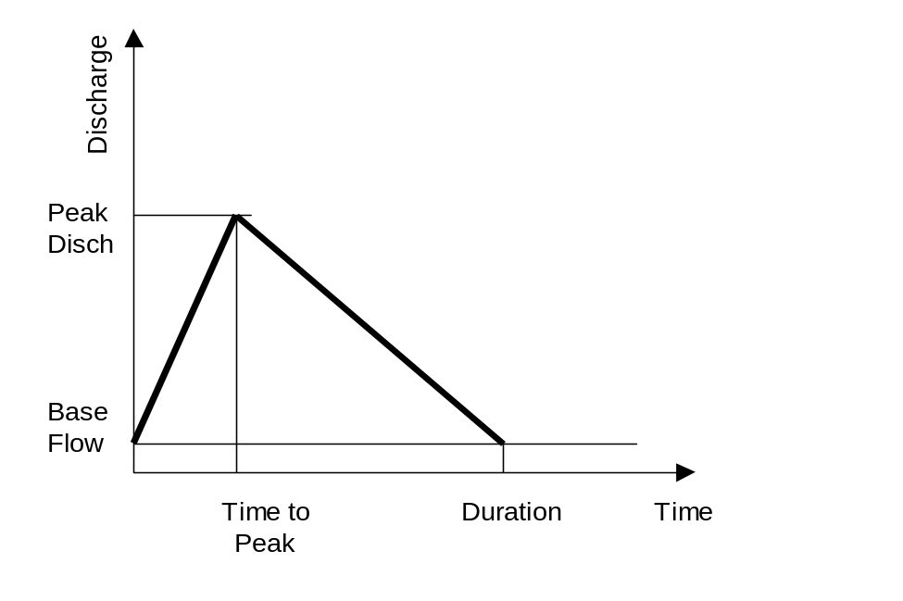The hydrographs are described by a Base Flow Discharge and a Peak Discharge, both in cubic meters per second. The specification also requires a Time to Peak Discharge, and the Total Duration of the storm, both in hours. The figure below illustrates a typical hydrograph.
Sediment inflow for each subwatershed is specified through daily loads for each of the sediment classes, defined as the total sediment inflow for the storm, in kilograms (kg).
Note that the total duration of a hydrograph is limited to 24 hours. However, if you specify a storm that exceeds the maximum duration by a couple of hours, the flow model can adjust the shape of the prescribed hydrograph. This adjustment preserves the peak discharge and the total water mass, but reduces the total duration to 24 hours.
You can specify the flow discharges and sediment loads by creating a single data file that contains hydrographs for any number of storm events. These values are internally converted to sediment fluxes, which are distributed in time according to the water triangular hydrograph. The peak sediment flux occurs at the time of peak discharge.
To create the input file for the flow and sediment transport models, follow the steps outlined in the section for the ASCII sub-format.
Note: Future releases of FRAME will feature a node-oriented input format, which should be more convenient to users who elect to discard the rainfall-runoff simulation and prefer to directly specify the flow hydrographs. In addition, the current limitation of 24-hour duration hydrographs will be eliminated.

Watershed-Oriented Format

ASCII Format
The easiest way to specify boundary conditions for the flow and sediment transport models is by creating an ASCII input file, either using a text editor, or by converting your data into the format described by this section.
The advantage of the watershed-oriented format is that it complies with the output design of many watershed models. Further, the specification of discharges and sediment loads is independent of the node numbering employed by the models. The same input file can be applied to different channel networks, as long as the computational channel network is based on the same Extracted Channel Network, which is created by the Landscape Analysis model TOPAZ. Nodes created by the Channel Analysis module or by insertion of hydraulic structures are automatically taken care of, during the conversion process performed by the channel model.
The general format of the input file is shown on the next page:

Comment Line 1 (mandatory)
NumStorms NumSubwatersheds NumSedClasses
YearX1 DayY1 SubwatershedS1 QPeak QBase Duration TimeToPeak S1 S2 SN
YearX1 DayY1 SubwatershedS2 QPeak QBase Duration TimeToPeak S1 S2 SN
YearX1 DayY1 SubwatershedS3 QPeak QBase Duration TimeToPeak S1 S2 SN
. . . . . . . . . . . . . . . . . . . . . . . . . . . . . . . . . . . . . . .
YearX1 DayY2 SubwatershedSN QPeak QBase Duration TimeToPeak S1 S2 SN
YearX1 DayY2 SubwatershedS1 QPeak QBase Duration TimeToPeak S1 S2 SN
. . . . . . . . . . . . . . . . . . . . . . . . . . . . . . . . . . . . . . .
YearX1 DayY2 SubwatershedSN QPeak QBase Duration TimeToPeak S1 S2 SN

where:
NumStorms is an integer that contains the number of storms in the file.
NumSubwatersheds is an integer that specifies the number of subwatersheds for the channel network.
NumSedClasses is an integer number that contains the number of sediment size classes for which you are specifying sediment loads as input, in this file. Note that this value does not affect how many sediment classes will be used in the simulations. The maximum value is the total number of size classes used in the sediment transport simulation, currently set to 9 sediment classes. You can specify a value of zero, if you are not providing sediment any sediment inflow.
YearX is an integer number that identifies the calendar year for the storm,
DayY is an integer number between 1 and 365 that identifies the calendar day for the storm,
SubwatershedS1 is an integer number that identifies the subwatershed number 1,
SubwatershedSN is an integer number that identifies the highest numbered subwatershed, and equals to the total number of subwatersheds for the channel network in question.
QPeak is a floating-point number that specifies the Peak Discharge, in cubic meters per second, of outflow of that particular subwatershed. A value of 0.000 can be specified.
Qbase is a floating-point number that specifies the Base Flow Discharge, in cubic meters per second, of outflow of that particular subwatershed. A value of 0.000 can be specified.
Duration is a floating-point number that specifies the Total Duration of the storm, in hours, for the particular hydrograph. This value should not exceed 24 hours, although the flow model is able to modify the shape of the hydrograph so that this limit is internally enforced.
TimeToPeak is a floating-point number that specifies the time the peak discharge is reached, from the beginning of the storm, in hours.
S1 through SN are floating-point numbers that specify the daily sediment load in kilograms, for each size class between Class 1 (finer) and Class N (coarser), for that particular storm and subwatershed. Note that the number of entries (columns) in the file should correspond to the value of NumSedClasses, in the second line of the file. Furthermore, you must specify values for the finer classes, even if there is not sediment inflow. If you have inflow for classes 3 to 5, for example, you must set NumSedClasses to 5, and use 0.00 for classes 1 and 2.
The first seven fields, which specify water discharges, are required. Use zeros if there is no inflow for a particular subwatershed. Use one or more spaces to separate each field. Do not use decimal points in the integer fields (Year, Day, and Subwatershed). Use the decimal point in the remaining fields, even if the value you are specifying is an integer number.
The Year and Day fields are not used by the current version of the flow model. The first line is ignored by the program. However, it is required and its omission will lead to erroneous specification of the hydrographs. Unlike other FRAME input files, comments are not allowed in the body of the file.

Input of the daily sediment load
FRAME allows you to specify sediment loads for any number of sediment classes. The sediment transport model converts the supplied mass in kilograms into discharges (mass fluxes) in cubic meters per second. However, each size class is pre-defined by the program, according to the table below.

BEAMS Sediment Size Classes
Diam  (mm) | 1 | 2 | 3 | 4 | 5 | 6 | 7 | 8 | 9
Min | 0.010 | 0.025 | 0.065 | 0.250 | 0.841 | 2.000 | 4.000 | 8.000 | 22.627
Max | 0.025 | 0.065 | 0.250 | 0.250 | 2.000 | 4.000 | 8.000 | 22.267 | 50.000
Repres | 0.016 | 0.040 | 0.127 | 0.458 | 1.297 | 2.828 | 5.657 | 13.454 | 33.636

How to create a boundary conditions file
Creating a boundary conditions file for a channel network is not hard, since FRAME has all the necessary data organized into its database. The following example illustrates all steps of the process, using the data for Goodwin Creek, provided with the Example Problem of Chapter 4.
In this example, the numerical values are based on the rainfall-runoff simulation of a large storm that took place in December, 1989. This input file contains a single storm. The boundary conditions for the channel network simulation are specified at the beginning of each channel, and at a single internal node, which in this case represents the outflow of a subwatershed whose channel is not part of the current channel network. The characteristics of the triangular hydrographs at those nodes are assumed known.

Use the following procedure to gather the data about the channel network and the corresponding subwatersheds:
- Locate, in the Computational Channel Network window, all source nodes. You can use any of the ArcView standard features to query the database, add node numbers as labels, etc. One of the easiest ways is to use the Identify tool . Zoom-in on the node of interest, select the tool, and click on the source node. Write down the values of the fields “Node ID” and “FRAME Node Number.” For example, for the first tributary near the watershed outlet, the source node has FRAME Node Number equal to 1, and the FRAME ID is also equal to 1.
- Repeat step 1 for each source node, or any node for which you would like to specify inflow.
- In the Project window, select the Database icon . Look for the table entitle “Computational Network: Subwatershed Database Table,” then click the Open button. Look for the total number of records in this table, which can be seen in a data field in ArcView’s main menu, just below the line of buttons. The first number is the number of records currently selected, and the second number is the total number of records in the table, that is, the total number of subwatersheds. Write down that second number. In the present example, it should read 138.
- Click the name of the field “DS Nd ID” to select it. This column contains ID numbers for all nodes located at the outlets of subwatersheds. Click the Sort Ascending option in the Field menu, or use the corresponding button. Now you have the table sorted according to the node IDs that receive inflow for subwatersheds.
- Locate node IDs in the “DS Nd ID” column that correspond to each node ID you wrote down in step 1. Note that for many nodes there is more than one record. Some nodes receive the contribution from more than one subwatershed, and each record (line) in the table represents a subwatershed. Write down the “SWAT No.” of these subwatersheds. For example, for the Node ID equal to 1, you will see two records, whose SWAT numbers are 131 and 132. This means that the outflow of both subwatersheds are combined and prescribed as inflow at node 1 of the channel flow model. If you already have the inflow hydrograph at that location, you can prescribe it as the outflow of either watershed.
The information you gathered so far is summarized in the following table:

Node No. | Node ID | Subwatersheds
1 | 1 | 131,132
8 | 4 | 126, 127
22 | 6 | 119, 120
38 | 12 | 105, 106
53 | 15 | 101, 102
78 | 24 | 85, 86
81 | 27 | 78, 79
135 | 42 | 58, 59
189 | 60 | 33, 34
200 | 67 | 24, 25
239 | 82 | 6, 7

The nodes above are the source nodes of the channel network for the Goodwin Creek watershed, defined as in the Example Application of Chapter 4. The Node Numbers may differ if you added some nodes to the network. However, watershed numbers and Node IDs should be the same, if the network was extracted with the parameters prescribed in that problem. The last entry in the table above refers to a node in the middle of the main channel, some 900 meters upstream of the watershed outlet. It is include here to illustrate that the contribution of a watershed whose drainage channel is not a part of the computational network is easily accounted for by simply specifying a flow hydrograph at that location.

Assuming you have the values for the triangular hydrographs (Base Flow, Peak Discharge, Duration, and Time to Peak Discharge), you are ready to create the Boundary Conditions File. Using any text editor, create a file according to the format given at the beginning of this section, remembering that:
- The first line is reserved for comments. You can write anything in this line because its contents are ignored by the program. Caution: this comment line must be present in your input file!
- You can include any number of storm events in the file. Remember that for each storm, you must specify a line of data for each subwatershed related to your channel network. The number of lines for each storm, in case of Goodwin Creek, should be 138.
- Use decimal points for the floating-point quantities; do not use them for integer quantities.
The following are the first and last lines of the input file described in this example. See the file Goodwin_1.bc in the tutorial directory for a complete single-storm file.
# Inflow at source nodes + 1 interior node; Subwshds:138 Storms:1 SedCl: 3
1 138 3
1 1 1 0.0000 0.0000 0.0000 0.0000 0.0000 0.0000 0.0000
1 1 2 0.0000 0.0000 0.0000 0.0000 0.0000 0.0000 0.0000
1 1 3 0.0000 0.0000 0.0000 0.0000 0.0000 0.0000 0.0000
1 1 4 0.0000 0.0000 0.0000 0.0000 0.0000 0.0000 0.0000
1 1 5 0.0000 0.0000 0.0000 0.0000 0.0000 0.0000 0.0000
1 1 6 0.0900 0.0000 23.3072 9.1038 457.8900 28.6200 85.8500
1 1 7 0.0000 0.0000 0.0000 0.0000 0.0000 0.0000 0.0000
1 1 8 0.0000 0.0000 0.0000 0.0000 0.0000 0.0000 0.0000
. . . . . . . . . . . . . . . . . . . . . . . . . . . . . . . . . . . . . .
. . . . . . . . . . . . . . . . . . . . . . . . . . . . . . . . . . . . . .
. . . . . . . . . . . . . . . . . . . . . . . . . . . . . . . . . . . . . .
1 1 130 0.0000 0.0000 0.0000 0.0000 0.0000 0.0000 0.0000
1 1 131 0.0865 0.0000 22.8235 9.2978 230.0500 14.0300 36.4700
1 1 132 0.0000 0.0000 0.0000 0.0000 0.0000 0.0000 0.0000
1 1 133 0.0000 0.0000 0.0000 0.0000 0.0000 0.0000 0.0000
1 1 134 0.0000 0.0000 0.0000 0.0000 0.0000 0.0000 0.0000
1 1 135 0.0000 0.0000 0.0000 0.0000 0.0000 0.0000 0.0000
1 1 136 0.0000 0.0000 0.0000 0.0000 0.0000 0.0000 0.0000
1 1 137 0.0000 0.0000 0.0000 0.0000 0.0000 0.0000 0.0000
1 1 138 0.0000 0.0000 0.0000 0.0000 0.0000 0.0000 0.0000

Unformatted Format
You can also create a Fortran Unformatted file that contains the boundary conditions data. The data format is essentially the same as for the ASCII file, described in the previous section. This file is used created by the watershed model SWAT, and it uses only three sediment classes that range from fine silt to fine sand. If you are writing your own program to create the boundary conditions file, and the sediment inflow is limited to the three finer sediment size classes, you may want to use an unformatted file.
The advantage of the Unformatted file as opposed to the ASCII file is the resulting file size. The Unformatted file size is typically 40 percent smaller. The main disadvantage is that the file has to be created by a program compiled for the same machine architecture you intend to perform the simulations. A file created on a certain Unix system may not work on a Windows based system, for example. For this compatibility reason, Fortran unformatted files will not be used in future versions of FRAME. Another minor disadvantage is that you cannot see the file contents with a text editor, which can also be true for the ASCII files because they are usually too big for most text editors to handle.
The Unformatted file format does not contain comment lines, but two additional data lines at the beginning of the file.
The unformatted file can be created using following FORTRAN code similar to:

OPEN(UNIT=FileUnit, FILE=FileName, ACCESS='SEQUENTIAL',
& FORM='UNFORMATTED')
WRITE(FileUnit) VersionCode
WRITE(FileUnit) BcdTypeCode NumSubw, NumDays
DO NDY = 1, NumDays
DO NSW = 1,NumSubw
WRITE(FileUnit) YearY, DayD, SubwatershedNSW, Qpeak, Qbase,
& Duration, TimeToPeak, S1, S2, S3
ENDDO
ENDDO
Where:
VersionCode is an integer, set to 1.
BcdTypeCode is an integer, set to 1
NumSubw is an integer indicating the number of subwatersheds related to the channel network.
NumDays is an integer denoting the number of days, or storm events.
FileUnit is an integer containing the file identifier.
FileName is a string containing the output file name.
See the previous section for the types and contents of other variables.

Colormap File
The user can specify a new color scheme for displaying DEMs within FRAME. Colors are specified using RGB (red, green and blue) values.
The colormap file consists of 256 RGB triplets that define the colors to be assigned to the different elevations. The first triplet defines the color for the lowest elevation in the DEM; the 256th entry defines the color for the highest elevation.
The colormap file must contain exactly 256 lines. The file must have the extension .map and must be copied into the FRAME installation directory tree, in $FRAMEHOME/lib/colormaps.

